**PREVALENCE OF REFRACTIVE ERRORS AND TYPES OF AMBLYOPIA IN A RURAL POPULATION OF MULLANA, HARYANA, INDIA**

# **PROJECT SUBMITTED TO**

**MAHARISHI MARKANDESHWAR INSTITUTE OF MEDICAL SCIENCES AND RESEARCH, MM (DU), MULLANA, AMBALA, HARYANA, INDIA**

# mmu logo

**In partial fulfillments of the requirements for the degree**

**Bachelor of Optometry**

**(2018-2022)**

**SUBMITTED BY**

**AMAN SINGH**

**ROLL NO 1618622**



**DECLARATION**

I Hereby declare that this project entitled **“ PREVALENCE OF REFRACTIVE ERRORS AND TYPES OF AMBLYOPIA IN A RURAL POPULATION OF MULLANA,HARYANA,INDIA”** is an outcome of original research work undertaken and carried out by me ,under the guidance of **Dr. Nitesh Pradhan** Assistant Professor of optometry, Maharishi Markandeshwar Institute of Medical Sciences and Research, Mullana ,Ambala, Haryana .This is an original work submitted only to Maharishi Markandeshwar (Deemed to be University),Mullana, Ambala, Haryana and is free of any plagiarism at the time of submission.

**DATE: AMAN SINGH**

**ROLL NO 1618622**

**B.OPTOMETRY INTERN**

Maharishi Markandeshwar Institute of Medical Sciences and Research, Mullana, Ambala, Haryana



**CERTIFICATE**

This is to certify that work embodied in that this project entitled **“PREVALENCE OF REFRACTIVE ERRORS AND TYPES OF AMBLYOPIA IN A RURAL POPULATION OF MULLANA, HARYANA, INDIA”** is being submitted by **Aman Singh** **(Roll no, 1618622**) for the award of the degree of **Bachelor of Optometry (B.Optometry)** to the Maharishi Markandeshwar (Deemed to be University),is a bonafide project work done by his under my supervision. This is an original work submitted only to Maharishi Markandeshwar (Deemed to be University) ,Mullana, Ambala, Haryana and is free of any plagiarism at the time of submission.

**Guide By:**

**DATE: Dr. Nitesh Pradhan**

**Assistant Professor of Optometry**

**Department of Ophthalmology**

**Maharishi Markandeshwar Institute of Medical Sciences and Research, Mullana, Ambala, Haryana**



**CERTIFICATE**

This is to certify that work embodied in that this project entitled **“PREVALENCE OF REFRACTIVE ERRORS AND TYPES OF AMBLYOPIA IN A RURAL POPULATION OF MULLANA, HARYANA, INDIA”** is being submitted by **Aman Singh (Roll no, 1618622**) for the award of the degree of **Bachelor of Optometry (B.Optometry)** to the Maharishi Markandeshwar (Deemed to be University),is a bonafide project work done by his under my co-supervision. This is an original work submitted only to Maharishi Markandeshwar (Deemed to be University), Mullana, Ambala, Haryana and is free of any plagiarism at the time of submission.

**Co-Guide By:**

**DATE: Mr. Om Shankar Kamat**

**Assistant Professor of Optometry**

**Department of Ophthalmology**

**Maharishi Markandeshwar Institute of Medical Sciences and Research, Mullana, Ambala, Haryana**

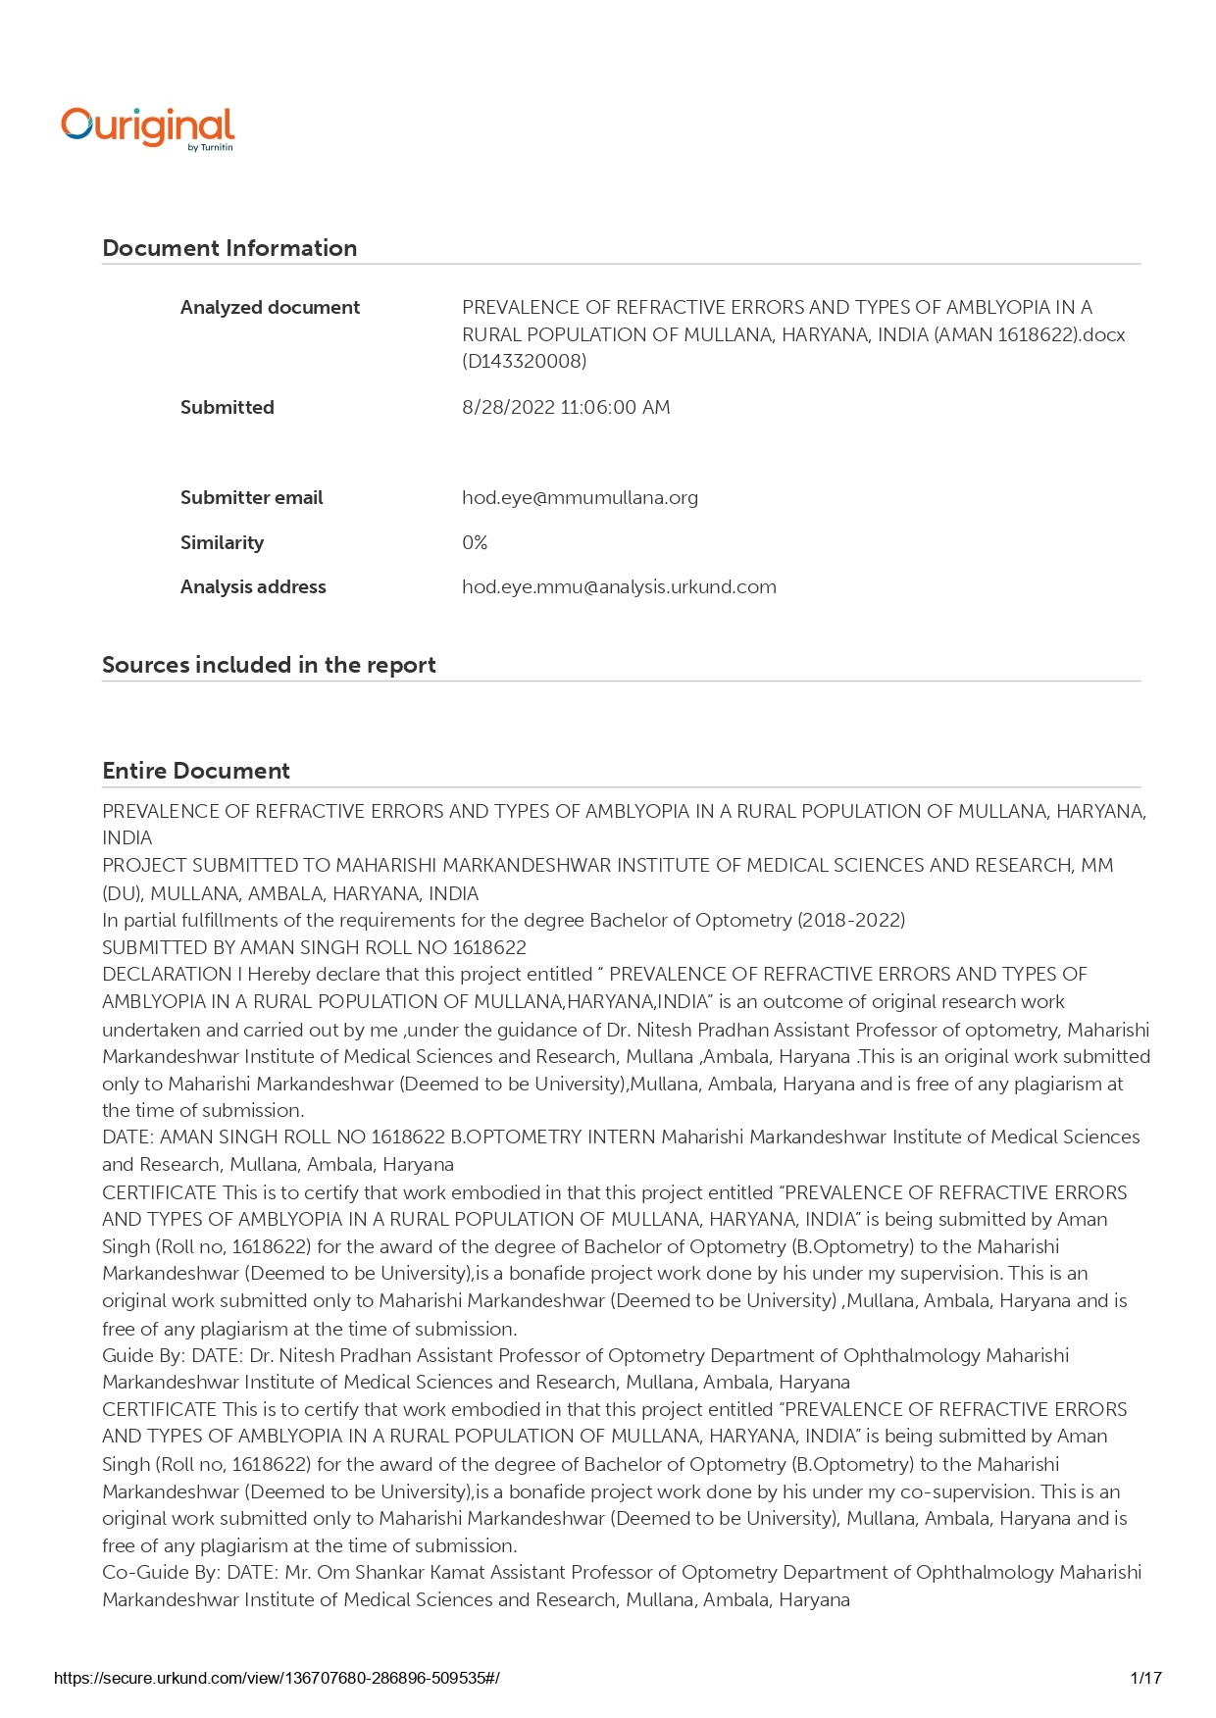

# **ABSTRACT**

**Background:** The most frequent cause of monocular vision loss in children is amblyopia, also known as lazy eye. Since amblyopia is a major preventable and treatable cause of paediatric low vision, it is crucial to identify and treat it as soon as possible in order to lower the prevalence of amblyopia. An avoidable cause of vision impairment is refractive error.Children don't typically complain about visual issues. This justifies the early identification and treatment of these issues to stop further blindness.

**Aims**: To ascertain the frequency of amblyopia as well as the kind, pattern, and severity of refractive error in children with amblyopia in a MULLANA, AMBALA, and HARYANA

**Study Design:** Cross sectional Study

**Method:** 25 randomly chosen students made up this population-based cross-sectional study. Snellen charts were used to assess visual acuity. Retinoscopy and the autorefractometer were used to measure the refractive errors, and the cover test was used to screen for strabismus. The fundus, red reflex, lens opacities, and anterior segment were all evaluated by direct ophthalmoscopy. Best corrected visual acuity in one or both eyes of 6/12 or 20/40 without any anatomical issues was used to identify functional amblyopia.

**Result:** Study was conducted on 51 patients between the age group of 14-45 years, in the Department of Ophthalmology of Maharishi Markandeshwar Institute of Medical Science and Research, Mullana, Ambala. In our Study, Females 27 (13.37±10.49) are more affecting than Males 24 (9.92±5.99) patients but the data was not significant with Pen. In our Study, Females 27 (16.81±12.12) are more affecting than Males 24 (12.04±6.15) patients but the data was not significant with RAF Ruler.

**Conclusion:** In our study, we found that NPA with RAF ruler had significant differences in comparison to NPA with PEN.

**Keywords**: Accommodation, Pen push up exercises., hard chart exercise ,Brock string (distance) chart

**ACKNOWLEDGEMENT**

I want to acknowledge the contribution of all the people spared their precious time for the completion of this research project.

I would like to express heartful gratitude to respected **teacher Dr. Nitesh Pradhan (Assistant Professor of Optometry)** for his comprehensive guidance until the work came to existence.

Special thanks to **Mr. Ritesh Kumar Chaurasia (Assistant Professor of Optometry)** who was always ready to co- guide throughout the research Project.

I am thankful to my parents for their constant support and my friends.

**AMAN SINGH**

# **Table of Contents**

|  |  |  |
| --- | --- | --- |
| 1. No | Contents | Page number |
| 1 | Introduction | 1-5 |
| 2 | Review of Literature | -13 |
| 3 | Aims and Objectives | 14 |
| 4 | Methodology | 120 |
| 5 | Result and Analysis | 21-23 |
| 6 | Discussion | 24 |
| 7 | Conclusion and Limitations | 25 |
| 8 | References | 26-28 |
| 9 | Abbreviations & Annexures | 29-31 |
| 10 | Master Chart | 32-33 |

# **TABLE OF FIGURES**

|  |  |  |
| --- | --- | --- |
| 1. No | Contents | Page number |
| 1 | Fig no. 1 Effects of accommodation on divergent rays entering the eye | 1 |
| 2 | Figure 1.2 Far point in emmetropic eye(a), myopic eye(b),and hypermetropic (c) | 2 |
| 3 | Fig. 3 Decrease in the amplitude of accommodation with age in human | 3 |
| 4 | Fig no. 4 RAF Rule | 4 |
| 5 | Figure:5 Examiner Doing Retinoscopy | 17 |
| 6 | Figure 6 showing Snellen Visual acuity examination | 17 |
| 7 | Figure: 7 Examiner Doing NCT | 18 |
| 8 | Figure: 8 , Examiner Doing NPA with Accommodative Target | 19 |
| 9 | Figure:9 Examiner doing NPA with RAF Ruler | 20 |
| 10 | Figure:10 RAF Ruler | 20 |
| 11 | Figure 11 showed NPA with RAF Ruler and NPA with pen | 21 |
| 12 | Figure 12 Gender wise distributions NPA with Pen | 22 |
| 13 | Figure 13 Gender wise distributions NPA with RAF Ruler | 23 |

# **Description: C:\Documents and Settings\Mukesh\Desktop\Backup_of_Untitled-2.jpg**

# **Introduction**

**INTRODUCTION**

**REFRACTIVE ERROR**

Refractive error, sometimes referred to as refraction error, occurs when the cornea or eye's shape prevents light from being focused correctly on the retina. Nearsightedness, farsightedness, astigmatism, and presbyopia are the most prevalent kinds of refractive error. Far-off items get fuzzy with near-sightedness, close-up objects become blurry with far-sightedness and presbyopia, and objects seem stretched out or hazy with astigmatism. Double vision, headaches, and eye strain are some more signs.(1)

Astigmatism is caused by the cornea's incorrect form, nearsightedness by the eyeball being too long, farsightedness by the eyeball being too short, astigmatism by the cornea's incorrect shape, and presbyopia by the lens of the eye becoming too old to change shape adequately. Some refractive defects affect people more frequently if their parents have them. Eye examination is used for diagnosis.(1)

Surgical correction, contact lenses, or spectacles are used to correct refractive defects. The simplest and most secure way to correct vision is using eyeglasses. Contact lens es can provide a wider field of vision; however they are associated with a risk of infection. The cornea's shape is permanently altered via refractive surgery.(1)

**MYOPIA**

When the accommodative system is at rest, myopia is a refractive condition of the eye in which parallel light rays from infinity concentrate in front of the retina. Short-sightedness is the most popular name for it. Since the primary focus point (F) of the myopic eye lies in front of the retina, the images created there are hazy. The prevalence of myopia changes with age and other associated factors. It is more common in premature infants than is normal, rises in school-age children and young adults, and slightly decreases in the population over the age of 45, remaining at about 20 percent in people between the ages of 60 and 65 and 14 percent in people over the age of 70. According to several research, women have a higher risk of developing myopia than men do. Additionally, the likelihood is higher for people whose jobs require a lot of close work. Children with two myopic parents are more likely to develop the condition (35–60%) than those with only one (25-40%).(2)

|  |
| --- |
| Fig 1.1 parallel infinity-bound rays in myopia focus in front of the retina(3). |

**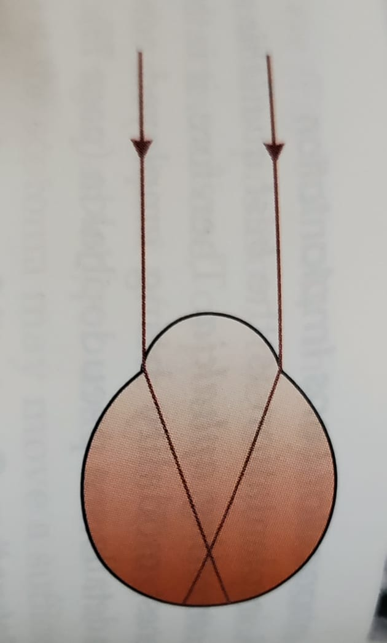CLASSIFICATION OF MYOPIA**

1 .DEGREE OF MYOPIA

The power of the ideal correction, which is expressed in diopters, is used to characterize the degree of myopia:(4)

Emmetropia is the typical classification for myopia between 0.00 and 0.50 diopters.

Low myopia is typically defined as myopia that ranges from 0.50 to 3.00 diopters. (5)

Typically, myopia between 3.00 and 6.00 diopters is referred to as moderate myopia. (5)  Myopia in the moderate range increases the risk of pigmentary glaucoma and pigment dispersion syndrome. (6)

Myopia of six or more is typically referred as as high myopia. (7)(8) High myopia patients are more prone to develop primary open angle glaucoma and retinal detachments(9)(10)  Additionally, floaters—shadowy shapes that emerge in the field of vision—are more common among them. (11)

2 .AETIOLOGICAL TYPES OF MYOPIA

1. AXIAL MYOPIA ; An increase in the eyeball's antero-posterior length causes axial myopia. It is the most prevalent kind.(12)
2. CURVATURAL MYOPIA; Increased corneal, lens, or both curvature can cause curvatural myopia.(12)
3. POSITIONAL MYOPIA; The anterior position of the crystalline lens in the eye causes positional myopia.(12)
4. INDEX MYOPIA; Increased nuclear sclerosis-related refractive index of the crystalline lens causes index myopia.(12)
5. MYOPIA DUE TO EXCESSIVE ACCOMODATION; myopia brought on by too much accommodation occurs in a patient with accommodation spasm.(12)

3. AGE OF ONSET

1. CONGENITAL MYOPIA; Infantile myopia, commonly referred to as congenital myopia, is a condition that begins at birth and lasts throughout infancy. (13)
2. YOUTH-ONSET MYOPIA; Myopia in young people normally develops in early childhood or adolescence, and the ocular power might continue to change up until the age of 21, when ophthalmologists generally do not advise any sort of corrective surgery. (13)
3. Childhood, especially the school-age years, is when children first develop school myopia. (14) The use of the eyes for close work during the academic years is blamed for this type of myopia. (15)

4. CLINICAL VARIETIES OF MYOPIA

* PATHOLOGICAL MYOPIA \DEGENERATIVE MYOPIA;

Up to 3% of people worldwide suffer from a subset of myopia known as pathologic myopia. (16) Pathologic myopia-related vision loss has significant therapeutic implications because it can be gradual, permanent, and afflict people in their prime working years. High myopia is characterized as having at least a -6.00D refractive error or an axial length of at least 26.5 mm (16) Early studies' definitions of pathologic myopia varied and frequently focused on the interaction between refractive error and axial length, which may only signify a severe case of myopia. Additionally, the proposed cutoff values were not supported by any convincing evidence. Pathologic myopia is now defined as "the presence of myopic maculopathy equal to or more severe than diffuse chorioretinal atrophy" in recent years. (17)

AETIOLOGY

The corresponding article goes into more detail about how myopia develops and how environmental and genetic factors are involved. At this time, it is unclear how known genetic variations associated with myopia contribute to the emergence of pathologic myopia. (18)

SYMPTOMS

* DEFECTIVE VISION; As the inaccuracy is typically high, there is a significant loss in visual function. A progressive degenerative condition may result in an irreversible loss of vision.(19)
* MUSCAE VOLITANTS; floating opacity of black in the eye.(19)
* NIGHT BLINDNESS; because of severe myopia's pronounced degenerative alterations.(19)

SIGNS

VISUAL ACUITY ; Distance visual acuity is substantially compromised, and the error is more severe than simple myopia. Refractive error rises steadily with an average of 3 to 4 D everyyear and rises significantly to 25 to 30 D till the age of 25 to 25 years. Occasionally, the error may rise steadily for the rest of one's life.(20)

* ANTERIOR SEGMENT; Exophthalmos or proptosis may be confused with eyes that have a large, prominent, eyeball, cornea seem to be big.Deep anterior chamber ,pupil size is greater.(20)
* FUNDUSEXAMINATION

This myopia may be characterized by choroidal crescent, supertraction crescent, choroidal atrophic patches, lacquer cracks, Forster fuch's flecks, posterior staphyloma, cystoid degeneration, lattic degenerations, paripapillary atrophy, or myopic or temporal crescent .(21)

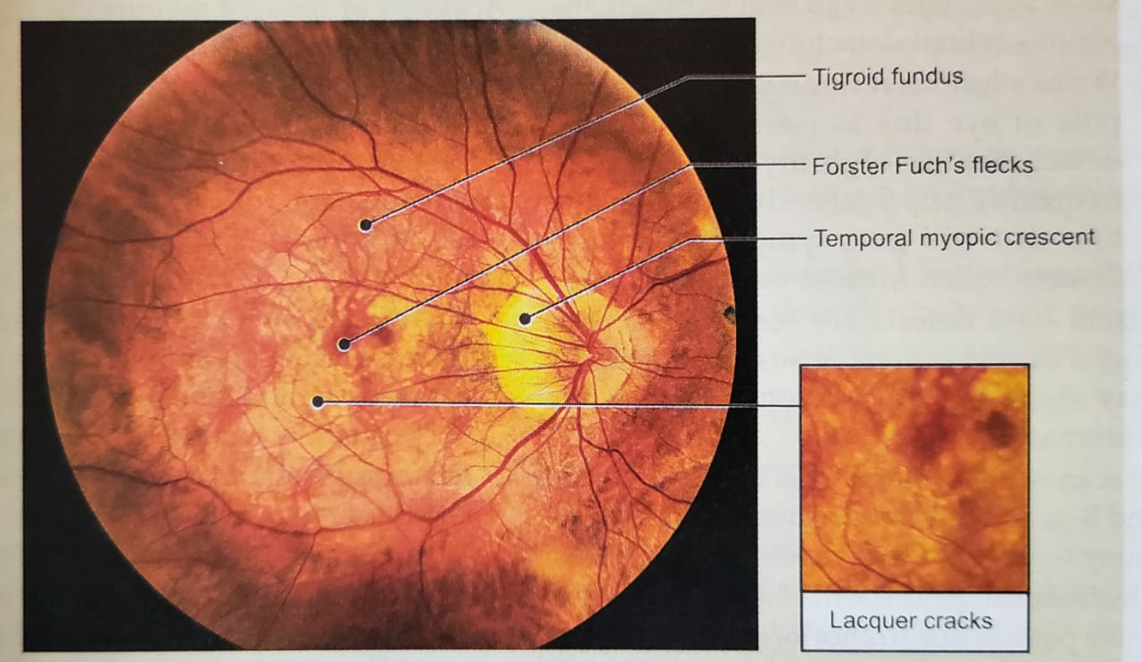

Fig. 1.2 MYOPIC FUNDUS (21)

5. PSEUDOMYOPIA ; Distance vision blurring due to accommodation system spasm is known as pseudomyopia.(22)

6 .NOCTURNAL MYOPIA ; Nighttime myopia: In the absence of sufficient stimulus for precise accommodation, the accommodation mechanism only partially engages, blurring distant objects.(23)

**TREATMENT**

* Optical treatment ; concave lens may be prescribed.

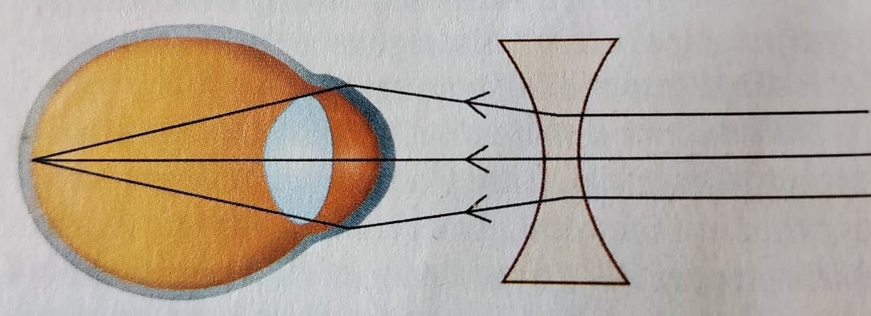

Fig 1.3 correction of myopia(24)

**SURGICAL TREATMENT**

* **LASIK** ; To give the excimer laser beam access to the exposed corneal tissue during the LASIK pre-procedure, a corneal flap is carved into the cornea and elevated. The tissue is then ablated by the excimer laser in accordance with the necessary adjustment. When the flap once more covers the cornea, the corneal surface experiences the curvature change caused by the laser ablation. Although LASIK is typically painless and requires little recovery time after surgery, it has the potential to cause flap problems and loss of corneal stability (post-LASIK keratectasia). (25)(26)
* **PHOTOREFRACTIVE KERATECTOMY** ; Using an excimer laser, photorefractive keratectomy (PRK) removes corneal tissue from the corneal surface. The degree of myopia is correlated with the degree of tissue ablation. Although PRK is a relatively safe operation for myopia up to 6 dioptres, the post-operative recovery period is typically uncomfortable. (27)(28)
* **ALTERNATIVE MEDICINE** ; Myopia has been allegedly improved by a number of alternative therapies, such as vision therapy, "behavioural optometry," various eye exercises and relaxation methods, and the Bates method. (29) Eye exercises "cannot be advised," according to scientific evaluations, as there is "no convincing scientific proof" that they are useful in curing nearsightedness.(30)

**HYPERMETROPIA**

Long-sightedness, often referred to as far-sightedness, hypermetropia, or hyperopia, is an ocular disease in which close objects appear blurry but distant ones are plainly seen. Due to inadequate accommodation by thelens, incoming light is directed behind the retina wall rather than directly on it, creating the fuzzy impression. (31)

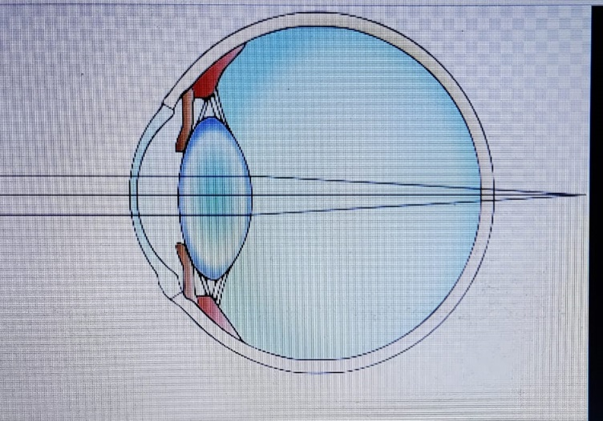

FIG.1.4 Long-sightedness, hyperopia, hypermetropia, (32)

**CLASSIFICATION OF HYPERMETROPIA**

**AETIOLOGICAL TYPES**

* AXIAL HYPERMETROPIA ; When the axial length of the eyeball is too short, axial hypermetropia results. A 3 diopter increase in hypermetropia results from a 1 mm decrease in axial length.(33)
* POSITIONAL HYPERMETROPIA ;  Positional hypermetropia results from posterior lens or IOL dislocation.(33)
* CONSICUTIVE HYPERMETROPIA ; Consecutive hypermetropia can result from under- or overcorrecting myopia surgically after cataract surgery.(33)
* CURVATURAL HYPERMETROPIA ; When the curvature of the lens or cornea is flatter than usual, curvaturalhypermetropia results. A 1 mm increase in the radius of curvature causes an increase in hypermetropia of 6 diopters.(33)
* FUNCTIONAL HYPERMETROPIA ; Functional hypermetropia is caused by accommodation paralysis, which can be seen in conditions like CN III palsy and internal ophthalmoplegia. (33)
* INDEX MYOPIA ;Hypermetropia may result from refractive index alterations brought on by aging (cortical sclerosis). Diabetes is a further factor in index hypermetropia.(33)
* ABSENCE OF LENS ; High degree hypermetropia is caused by either congenital or acquired aphakia.(34)

**ACCORDING TO SEVERITY**

THERE ARE THREEE GRADES OF HYPERMETROPIA(35)

* LOW ; less than or equal to +2.00 diopters of refractive error (D).
* MODERATE ; larger than +2.00 D and up to +5.00 D in the refractive index.
* HIGH ; larger than +5.00 D in the refractive error

CLINICAL CLASSIFICATION

THERE ARE THREE TYPES OF CLINICAL HYPERMETROPIA (35)

* SIMPLE HYPERMETROPIA ; naturally occurs as a result of biological diversity.
* PATHOLOGICAL HYPERMETROPIA ; resulting from illness, injury, or unusual development.
* FUNCTIONAL HYPERMETROPIA ; caused by paralysis, which prevents the eye from adjusting.

NOMENCLATURE OF HYPERMETROPIA COMPONENTS DEPENDING ON ACCOMMODATION'S IMPACT(36)

* TOTAL HYPERMETROPIA; It is determined how much refractive error there is after complete atropine and cycloplegia. It is made up of both latent and obvious hypermetropia.(36)
* LATENT HYPERMETROPIA; It means that the ciliary muscle's natural tone generally corrects a small degree of hypermetropia (around 1D). Latent hypermetropia is more severe in youngsters and lessens with time as people age.(36)
* MANIFEST HYPERMETROPIA ; The remaining amount of total hypermetropia is what ciliary tone does not correct. There are two parts to it: absolute and facultative hypermetropia.(36)
  1. FACULTATIVE HYPERMETROPIA ; The portion of facultative hypermetropia that the patient can correct by accommodating behavior.(36)
  2. ABSCOLUTE HYPERMETROPIA ; the uncorrectable portion of evident hypermetropia that remains after patient accommodation.(36)

SYMPTOMS ; Asymptomatic symptoms, such as mild photophobia and headaches, are asthenopic symptoms. vision impairment alone, vision impairment with asthenopic symptoms, and the impact of vision on aging(37)

SIGNS ; The eyeball shrinks, and the cornea might be slightly smaller than usual. relative shallow anterior chamber The optic disc could be thinner and appear more vascular. There can be a brief silk appearance. Axial hypermetropia causes an eyeball with a small anteroposterior length. (37)

COMPLICATIONS ; Strabismus and amblyopia are two uncommon problems associated with farsightedness. Young children with severe farsightedness may experience double vision as a result of "over-focusing." (38)

TREATMENT

OPTICAL TREATMENT ; CONVEX LENS AND CONTACT LENS SHOULD BE PRESCRIBED (39)

SURGICAL TREATMENT

* REFRACTIVE LENS EXCHANGE ; The replacement of the natural crystalline lens with an artificial intraocular lens in a variation of cataract surgery; the difference is the presence of defective ocular anatomy that results in a significant refractive error. (40)
* PHAKIC IOL ; The normal crystalline lens of the eye is not removed when phakic intraocular lenses are implanted. IOLs made of phakic material can treat hypermetropia up to +20 diopters. (41)
* EPI LASIK ; Hyperopia can also be treated using epi-LASIK. (41)  Alcohol is not used in this operation thanks to the epikeratome. (41)
* LASER THERMAL KERATOPLASTY ; A non-destructive refractive technique called laser thermal keratoplasty uses a laser to treat presbyopia and hyperopia. (41) Thallium-Holmium-Chromium (THC): YAG laser is employed. (41)
* LASER ASSISTED IN SITUE KERATOMILEUSIS (LASIK); With excimer laser LASIK, hypermetropia up to +6 diopters can be corrected.(42) Patients with lupus and rheumatoid arthritis should not have LASIK. (42)

**ASTIGMATISM ;**

Due to rotational asymmetry in the eye's refractive power, astigmatism is a type of refractive error. Any distance vision becomes warped or obscured as a result. (43) Other signs can include headaches, eyestrain, and difficulty driving at night. (43) Often present at birth, astigmatism might later develop or change. (44) It can lead to amblyopia if it develops early in infancy and is untreated. (45)

ETIOLOGICAL TYPES

* CORNEAL ASTIGMATISM ; astigmatism of the cornea It is brought on by irregularities in the cornea's curvature.(46)
* LENTICULAR ASTIGMATISM ;curvatural as a result of anomalies in the lens's curvature as seen in lenticonus. Situated as a result of the lens's oblique positioning, as seen in subluxation. Due to different meridian lenses' varied refractive indices, index astigmatism can occasionally arise.(46)
* RETINAL ASTIGMATISM ; Occasional oblique macula placement can also cause retinal astigmatism.(46)

ON THE BASIS OF AXIS OF PRINCIPLE MERIDIAN

* WITH THE RULE ASTIGMATISM ; The steepest meridian is the vertical one  than horizontal meridian(47)
* AGAINST THE RULE ASTIGMATISM ;The steepest meridian is the horizontal one than vertical meridian.(47)
* OBLIQUE ASTIGMATISM ; Between 120 and 150 degrees and 30 and 60 degrees is where the steepest curve is located.(47)
* BI OBLIQUE ASTIGMATISM ; Two primary meridian lines in this type of astigmatism are not parallel to one another, for example, one may be at 30 and the other at 100.(48)

ON THE BASIS OF TWO FOCAL POINT

* SIMPLE ASTIGMATISM
  1. SIMPLE MYOPIC ASTIGMATISM ; While the second focus line is on the retina, the first focal line is in front of the retina.FIG.1.5A(49)
  2. SIMPLE HYPERMETROPIC ASTIGMATISM ; While the second focus line is situated beneath the retina, the first focal line is on the retina.FIG.1.5B(49)
* COMPOUND ASTIGMATISM
  1. COMPOUND MYOPIC ASTIGMATISM ; In front of the retina, both focus lines are situated.FIG.1.5C(49)
  2. COMPOUND HYPERMETROPIC ASTIGMATISM ; Behind the retina, both focus lines can be found.FIG.1.5D(49)
* 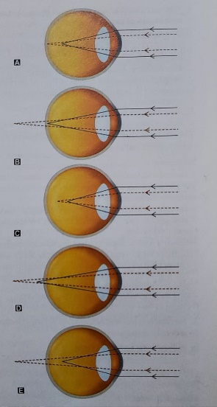MIXED ASTIGMATISM ; Both sides of the retina have focus lines.FIG.1.5E(49)

FIG.1.5 TYPES OF ASTIGMATISM ; (A)SIMPLE MYOPIC ; (B)SIMPLE HYPERMETROPIC ; (C)COMPOUND MYOPIC ; (D)COMPOUND HYPERMETROPIC ; (E) MIXED(49)

SYMPTOMS AND SIGNS

Higher levels of astigmatism may result in symptoms including double vision, blurred vision, squinting, eye strain, weariness, or headaches. Astigmatism may also be asymptomatic. (50) According to certain studies, astigmatism is associated with a higher incidence of migraine headaches. (51)

TREATMENT

Refractive surgery, contact lenses, or glasses can all be used to treat astigmatism. (52) The simplest and safest option is a pair of glasses, while contact lenses can offer a wider field of view. By permanently altering the structure of the eye, refractive surgery can completely eliminate the need for corrective lenses to be worn, but like all elective surgery, it carries higher risks and costs than less intrusive alternatives. If one choice could be preferable to another, a number of factors including eye health, refractive status, and lifestyle must be taken into account. Certain contact lenses can frequently help keratoconus patients attain superior visual acuity than eyeglasses. Toric lenses, which were previously exclusively accessible in a hard, gas-permeable form, are now being offered as soft lenses. (53)

For the treatment of concurrent corneal astigmatism in such complex instances, toric intraocular lenses appear to be just as effective as in non-complex ones. (54)

**AMBLYOPIA**

Amblyopia, commonly known as lazy eye, is a vision disease in which one eye's visual information is incompletely processed by the brain, which eventually causes it to favor the other eye. (55) In an eye that normally appears normal in other ways, it causes impaired vision. (55) The most frequent reason for reduced vision in a single eye in kids and younger people is amblyopia. (55) This may result from poor eye alignment (strabismus), an unusually shaped eye that makes concentrating challenging, more nearsightedness in one eye than the other (refractive), or clouding of the lens of one eye (deprivational). (55) For all children between the ages of four and five, vision testing is advised because amblyopia can be challenging to identify. (56) According to estimates, 1 to 5 percent of adults in the population have the disorder. (57)

AMBLYOGENIC FACTORS

UNAVAILABILITY OF VISION ;Strabismic, anisometropic, stimulus-deprivation amblyopia is caused by monocular visual deprivation, which acts as an amblyogenic factor. When a child has a bilateral high degree of refractive error, ametropia, and cataract, binocular deprivation plays a role in amblyogenesis.(58)

LIGHT IMPAIRMENT ; In children with unilateral or bilateral cataract, lack of light acts as an amblyogenic cause.(58)

BINOCULAR INTERACTION THAT IS NOT USUAL ; Due to a competition amblyopia, it causes a profound amblyopia. In children with strabismic, anisometropic, and unilateral stimulus deprivation amblyopia, it acts as an amblyogenic factor. (58)

TYPES OF AMBLYOPIA

1. STRABISMIC AMBLYOPIA

Strabismic amblyopia develops in kids with a unilateral continuous squint who fixate with their normal eye due to protracted uniocular suppression. (59)

1. STIMULUS DEPRIVATION AMBLYOPIA

Ex anopsia is another name for it. It manifests as complete ptosis, dense central corneal opacity, and congenital or traumatic cataract when one eye is completely excluded from vision early in life. (59)

1. ANISOMETROPIC AMBLYOPIA

It happens in an eye that has more refractive error than the other eye. Compared to children with anisomyopia, it affects anisohypermetropic more frequently. While myopic anisometropia up to 3D normally does not cause amblyopia, even 1-2 D hypermetropicanisometropia has the potential to do so. (59)

1. ISOMETROPIC AMBLYOPIA

Children with bilateral uncorrected high refractive error experience bilateral amblyopia. (59)

1. MERIDIONAL AMBLYOPIA

Children with untreated astigmatic refractive error experience it. It is an amblyopia that only affects a certain visual meridian. (59)

SIGN AND SYMPTOMS

Since stereo vision requires both eyes, people with amblyopia often have poor stereo vision. They additionally could have poor pattern recognition, poor visual acuity, and reduced sensitivity to contrast and motion in the affected eye. (60)

In addition to reduced visual acuity, altered spatial interactions, and impaired contour detection, amblyopia is characterized by a number of functional abnormalities in spatial vision. These include reductions in vernier acuity, contrast sensitivity function, and visual acuity, as well as spatial distortion. A person with amblyopia also has improper binocular summation and impaired stereoacuity (stereoscopic acuity), among other binocular abnormalities. (61) Additionally, compared to normal observers, amblyopes have more cluttered central vision. (62)

Amblyopic individuals also experience binocular vision issues, such as reduced stereoscopic depth perception, and typically struggle to make out the three-dimensional elements in autostereograms and other hidden stereoscopic displays. (63)

TREATMENT

Early intervention is recommended for amblyopia treatment .(64)

1. OCCLUSION THERAPY

The mainstay of treating amblyopia is occluding the healthy (normal) eye to force use of the amblyopic eye.

* If there is any opacity in the media, such as a cataract, it should be removed first.
* If there is any refractive error, it should be completely repaired.
* Occlusion should be performed in 2:1 increments up to 2 years, meaning 2 days in the healthy eye and 1 day in the amblyopic eye.
* 3:1 at the age of 3 years.
* 4:1, at the age of four.
* At age 5, the ratio is 5:1.
* When they are 6 years old, 6:1

Occlusion should last for three months or until visual acuity has fully developed, whichever comes first.

2. PENALIZATION

When occlusion is not an option, blurring of the normal eye's vision can be achieved either by employing atropine (atropine penalization) or by utilizing over plus lenses in spectacles (optical penalization).

3. PLEOPTIC EXERCISE

In the past, pleoptic exercises were advised to restore foveal fixation, particularly in young children.

4. PHARMACOLOGIC MANIULATION

Carbidopa has been investigated as an adjuvant to occlusion therapy when used pharmacologically with levodopa.

5.COMPUTERIZED VISION THERAPHY

complementary medicine to occlusion therapy.(64)

****

# **REVIEW OF LITERATURE**

**REVIEW OF LITERATURES**

* **Epelbaum et al.,(1993)(65**) The time frame during which 407 kids, whose ages ranged from 21 months to 12 years, were susceptible to monocular occlusion was examined in order to determine the sensitivity period for strabismic amblyopia.Between 1975 and 1990, patients were treated by occluding the best eye. The ratio of the amblyopia reduction at the conclusion of the occlusion was used to gauge the effectiveness of the treatment.The effectiveness of the occlusion is shown to depend on when the treatment was started. The recovery of the amblyopic eye's acuity was at its highest when the occlusion was started before the patient was three years old, declined as the patient aged, and was nearly nonexistent by the time the patient was 12 years old.This is thought to be a sign of the human strabismic amblyopia sensitive phase. The findings are reviewed in light of the amblyopia neurophysiological mechanisms discovered in animal models.
* **Murthy et al.,(2002)(66**)To determine the frequency of refractive error and the associated visual impairment in school-aged children in a city near New Delhi, India.A sample of children aged 5 to 15 was chosen at random from geographically distinct clusters. Children in 22 chosen clusters were counted by a door-to-door survey from December 2000 to March 2001, and they were also assessed at a nearby facility. Measurements of visual acuity, an assessment of ocular motility, retinoscopy and autorefraction while the patient was cycloplegic, and examinations of the anterior segment, media, and fundus were all part of the examination. Spherical equivalent refractive error of at least 0.50 D was used to characterize myopia, while +2.00 D or more was used to describe hyperopia. In four of the clusters, children with decreased vision and a sample of children with normal vision received independent duplicate exams for quality control.A total of 7008 kids from 3426 homes were counted, and 6447 (92.0%) of those were evaluated. The prevalence of 20/40 or lower visual acuity in the better eye with uncorrected, baseline (presenting), and greatest correction was 6.4%, 4.9%, and 0.81%, respectively. In 81.7% of the eyes with vision impairment, refractive error was the reason, followed by amblyopia in 4.4%, retinal diseases in 4.7%, other causes in 3.3%, and unexplained causes in 5.9%. Refractive error changed with age, moving from hyperopia in early children (15.6% at age 5) to myopia in older children (10.8% at age 15). In all, 7.7% of kids had hyperopia, and 7.4% had myopia. The presence of hyperopia was linked to feminine gender. Children of fathers with higher levels of education tended to have more myopia.In India, school-aged children with untreated refractive error have reduced eyesight, which is a significant public health issue. In order to eliminate this easily treated source of vision impairment, cost-effective measures are required.
* **Mohammad Faghihi et al., (2010)(67)**to find out how common refractive errors, strabismus, and amblyopia are among Iranian schoolchildren in Varamin city.In a cross-sectional population-based study conducted in 2010 among Varamin high school students, we employed random cluster sampling to choose the participants. Exams were given at the school location in accordance with protocol. All children underwent a cover test, non-cycloplegic refraction, and visual acuity (VA) test.Their mean age was 16.31.3 years, and 79.2% of the 1,430 people that were chosen took part in the study (range, 14 to 18). Myopia is common [spherical equivalent (SE) - 0.5 diopter (D)],With a 95% confidence interval (CI), hyperopia (SE+0.5 D) and hyperopia (SE+1.0 D) were 33.2% and 33.0%, respectively.17.5% (95% CI: 8.6 to 26.4), 6.1% (95% CI: 2.6 to 9.6), and 6.1% (95% CI: 2.6 to 9.6) are the various percentages. Astigmatism(cycling power 0.75 D) and anisometropia (difference in SE 1.0 D) were found in 10.5% of the samples.and 3.8% (95% CI: 1.8 to 5.8) of the students. (95% CI: 8.4 to 12.6).Exotropia was the most common kind of strabismus, accounting for 0.9% of all cases of strabismus, with a frequency of 1.5% (95% CI: 0.9 to 2.1).Exotropia was the most common kind of strabismus, accounting for 0.9% of all cases of strabismus, with a frequency of 1.5% (95% CI: 0.9 to 2.1).Amblyopia was present in 2.1% of people, and anisometropia accounted for 54.2% of those cases.15.4% (95% CI: 13.3 to 17.4) of the students had an unmet requirement for refractive correction.Myopia was the most prevalent refractive error among the students in this study, however hyperopia was more prevalent than in earlier studies. The requirement for refractive correction that went unmet was also greater. Strabismus was less common in this demographic than in others, although amblyopia was more common.
* **Pokharel et al.,(2010)(68)**An key contributor to childhood blindness and visual impairment is untreated refractive error.to research the types of refractive errors that Nepalese school-going children in urban and rural areas experience.Using a multi-stage randomization procedure, 440 students from urban and rural schools between the ages of 7 and 15 were chosen for this study.Refractive error was seen in 19.8% of school-aged children overall. Myopia (59.8%) and hypermetropia (31.0%) were the two most prevalent refractive errors among the students. When compared to their younger counterparts, children between the ages of 12 and 15 exhibited a higher prevalence of myopia (42.5% vs. 17.2%). Myopia affected 15.5% of urban students compared to 8.2% of rural students (RR = 1.89, 95% CI = 1.1-3.24). Urban students were more likely than rural pupils to have hypermetropia (6.4% vs. 5.9%; RR = 1.08; 95% CI: 0.52-2.24).In Nepal, 19.8% of school-aged children had refractive error. Compared to their counterparts from rural areas, metropolitan students are more likely to have refractive error.
* **SK Rai et al.,(2012)(69)**A significant contributor to childhood blindness and visual impairment is uncorrected refractive error.To define the kind of refractive defects that children with outpatient appointments at the Lumbini Eye Institute in Bhairahawa, Nepal's Department of Pediatric Ophthalmology tend to have.Patterns of refractive faults were looked for in the records of 133 children with refractive errors who visited the hospital between September and November 2010 and came from both urban and rural parts of Nepal and the neighboring territory of India. The children ranged in age from 5 to 15 years. The statistical program SPSS was used to analyze the data.Astigmatism (47%) was the most prevalent kind of refractive error among the kids, followed by myopia (34%) and hyperopia (15%). Children between the ages of 11 and 15 were more likely than their younger counterparts to have refractive error (RR = 1.22, 95% CI = 0.66 - 2.25). Refractive error was more prevalent in rural children (70%) than in urban children (26%). Myopia was more common among females in rural areas (38%) than in urban areas (18%). Only 57% of the children who had refractive problems were wearing glasses at the time of the initial presentation.The most prevalent refractive defect in children between the ages of 5 and 15 is astigmatism, which is followed by hypermetropia and myopia. A sizable portion of kids still have refractive errors.
* **K Sapkota et al.,(2013)(70)**Amblyopia frequently results from refractive error.In a tertiary eye hospital in Nepal, to ascertain the prevalence of amblyopia and the pattern and types of refractive error in children with amblyopia.From July 2006 to June 2011, a retrospective chart analysis of kids who were diagnosed with amblyopia at the Nepal Eye Hospital (NEH) was done. Children beyond the age of 13 and those with any visual pathology were not allowed. All youngsters underwent cycloplegic refraction and an ophthalmological examination. Refractive error patterns were identified, as well as relationships between different forms of refractive error and amblyopia.0.7% (440) of the 62,633 kids whose eyes were evaluated in the NEH during this time had amblyopia. The participants' amblyopic eyes were all refractively incorrect. The mean age of the patients was 7.74 2.97 years, and 248 (or 56% of them) were men. The most frequent factor contributing to amblyopia was anisometropia (p 0.001). Due to severe ametropia, one-third (29%) of the individuals developed bilateral amblyopia. With a visual acuity of 20/120 or worse, severe amblyopia affected 40% of the eyes. Astigmatism affected 59.2% or about two thirds of the eyes.The Nepal Eye Hospital has a 0.7% amblyopia prevalence rate. The most typical cause of amblyopia is anisometropia. The most prevalent types of refractive error in eyes with amblyopia is astigmatism.
* **MB Pavithra et al.,(2013)(71)**A preventable cause of visual impairment is refractive error. The simplest and most efficient methods of eye care are the diagnosis and treatment of refractive errors. to research the prevalence and factors associated with uncorrected refractive errors in school-age children (7 to 15 years old).A cross-sectional study of 1378 government schoolchildren in Bangalore's Dr. BR Ambedkar Medical College's rural and urban field practice regions, aged 7 to 15, was conducted. Snellen's chart was used to assess students for vision problems, and a refractionist confirmed the results. Free eyeglasses were given to students with refractive error. The prevalence of refractive errors among schoolchildren was examined using data.687 children from urban areas and 691 from rural areas underwent testing. Boys made up 53.6% of the study population while girls made up 46.4%. The study group's average age was 12.4 years. In both urban and rural youngsters, the prevalence of uncorrected refractive error was 7.03%. Children had a 4.4%, 1.03%, and 1.6% prevalence of myopia, hypermetropia, and astigmatism, respectively. Urban schoolchildren aged 13 to 15 were most likely to have untreated myopia. Female children and younger age groups were linked to hypermetropia.Older children were more likely to have uncorrected refractive error, particularly myopia. It is important to determine the root causes of the higher prevalence and to remove any obstacles to refractive error correction services. It is advised that schoolchildren have eye exams.
* **M Gupta et al.,(2016)(72)**One of the common causes of vision impairment in children is amblyopia. According to the age range of the population under study and the local conditions, amblyopia prevalence often varies. Around eight years old is the upper age at which amblyopia can develop, and if preventative steps are not implemented in a timely manner, it may become permanent.The aim of the study was to determine the profile and pattern of amblyopia in children in Uttarakhand who were 5 to 15 years old and had refractive error, and to compare it to studies from other countries and regions (South Asia).360 kids aged 5 to 15 who visited the OPD between September 2014 and February 2015 underwent thorough ophthalmic examinations as part of the current retrospective cross-sectional study. The study comprised children with eyesight 6/12 and no pathological lesions. Children with strabismus, eye disorders, and prior eye surgery were not included. Statistical analysis was performed using the Chi-Square test .Amblyopia affected 8.6% of the population (n=31), with no discernible gender differences (p>0.05). The overall prevalence of astigmatism-related amblyopia was 41.93% (n = 13), followed by hypermetropia (32.25%) (n = 10) and myopia (25.8%) (n = 8). Age of presentation was 5 to 10 years in 51.61% of cases, whereas > 10 years in the remaining instances. More people (58.06%) had binocular amblyopia than had unilateral amblyopia (41.93%).The second most frequent cause of pediatric amblyopia is refractive problems. Amblyopia and the related strabismus condition can have disastrous emotional and financial effects. Our research highlights the need of visual screening schoolchildren and providing them with the proper eyewear at the appropriate age.
* **Haile WA et al.,(2017)(73)**Amblyopia is a unilateral or bilateral disorder that causes reduced vision even while the eye appears to be in good health. This study's major goal was to quantify the prevalence and categorize the kinds of amblyopia among primary school students in Gondar, Northwest Ethiopia.In Gondar, Ethiopia, 1287 schoolchildren between the ages of 6 and 15 participated in a descriptive cross-sectional survey from January to February 2015. Qualified optometrists performed a thorough visual examination while organized check lists were employed to collect socio-demographic information. Children with presenting vision less than 6/9 were thoroughly investigated for case confirmation, and the kind of amblyopia was identified using best corrected visual acuity.The Statistical Package for Social Sciences PSS 16 software program was used to enter and analyze the data.4.7% of people had amblyopia (60). 38.3% of amblyopia cases are anisometropic and ametropic, whereas 6.7%, 8.3%, and 8.3% are contributed by strabismic amblyopia, visual deprivation amblyopia, and posterior segment abnormalities, respectively. The majority (55%/33) of cases of bilateral amblyopia were in females, who made up 56.7% of all cases (34).Amblyopia was prevalent to a significant degree in the studied area. For elementary school students in Gondar town, a school screening program for early detection and treatment is advised to lessen the burden of visual loss caused by amblyopia.
* **Pradhan et al.,(march2018) (74)**Since your eyes are one of the body's most vital organs and eyesight is one of God's greatest gifts, However, a lot of individuals frequently disregard the value of eye care and do not give it the attention it deserves. Four out of five of the estimated 180 million persons with visible disabilities—of whom almost 45 million are blind—live in developing nations. Uncorrected refractive defects are the second most common cause of blindness and impaired vision in India, accounting for 19.7% of all cases of these conditions. Blindness is one of the country's most serious societal concerns.Refractive error is an optical flaw that is inherent to the eye and reduces normal vision by preventing light from reaching the retina at a single point of focus. One of the simplest methods to lessen vision impairment is the very straightforward diagnosis and treatment of refractive problems. Astigmatism, hypermetropia (farsightedness), and myopia (nearsightedness) are the three basic categories of refractive defects.This research was carried out at several Haryanan schools. It includes 1000 pupils in the 6 to 12 year old age range enrolled in 6 rural (619 students) and 4 urban schools (381 students). Cases were characterized as having a vision of less than 6/6 without glasses. Following up with children and their parents was done to find out the reasons why they weren't wearing glasses even after the problem had been corrected following careful consideration of sociodemographic factors and a visual examination.According to the study, which included 620 students from rural schools and 380 students from urban schools, the prevalence of refractive errors is 7.0%, with myopia being the most common (61.9%), astigmatism being the second-most common (24.1%), and hypermetropia being the third-most common (14%) among children with refractive errors.Refractive error is on the rise these days due to edu-comp smart classes at school or use of laptops, TVs, computers, or mobile devices. If not detected early and treated promptly, complications including amblyopia and strabismus as well as other ocular pathologies may result.
* **Daigavane et.al.,(2018)(75**)To screen the kids coming into the ophthalmology OPD and to learn more about the characteristics and causes of amblyopia.An examination that was cross-sectional was carried out from August 2017 to February 2018. Children between the ages of 5 and 20 were included in the study. Children under the age of five were omitted due to examination resistance and poor communication. For 300 kids, visual acuity tests and ophthalmic pen-light examinations were done. Eight to twelve years old on average. There were 50 youngsters from metropolitan areas and 250 from rural ones. Children underwent a thorough eye examination, which included cycloplegic refraction, a slit lamp examination, and a fundus examination. The study comprised kids with eyesight 6/12 who had no pathological lesions.13 kids were amblyopic. Anisometropia 7 (53%), strabismus 3, isometropia 2, and deprivation 1 (8%) were the significant contributing factors. We saw 7 unilateral and 6 bilateral cases.Because of ignorance and illiteracy, parents are not informed. It is essential to upgrade the equipment used for routine eye exams, periodic eye screenings for refractive problems, strabismus testing, corneal blindness, and cataracts in schoolchildren. This study underlines the necessity of routine eye exams for school-aged youngsters. Amblyopia can have detrimental psychosocial and financial repercussions.
* **Ezhilvathani et al.,(2019)(76)**Childhood eye problems have a major negative impact on academic achievement and the future development and education of the child. With amblyopia screening, the current study intends to quantify the scope and patterns of refractive defects so that timely, efficient actions can be implemented to lessen the load.200 kids between the ages of 5 and 15 who were visiting the ophthalmology OPD of a tertiary healthcare facility in Puducherry were the subjects of a hospital-based cross-sectional study. Version 13.0 of SPSS was used for data interpretation and analysis.The average presentation age was nine. In the current study, the female to male ratio was 1.3:1. 48 children were found to have a favorable family history, indicating a significant hereditary influence on refractive errors. The most frequent refractive error among 20 kids who were already wearing glasses was compound myopic astigmatism. Among 30 children who were diagnosed with amblyopia, 8 children under the age of 8 had improved vision at the 1-month mark after receiving glasses and occlusion therapy, while 22 children showed no improvement, indicating that amblyopia can be treated if action is taken before the child reaches the age of 8.A key contributor to childhood visual impairment is refractive errors, whether or not they are accompanied by amblyopia.Despite being a hospital-based study, the findings agreed with those of earlier studies that were population- and hospital-based. Since refractive error is a serious public health issue around the world, this study was also planned to give primary care physicians a general picture of the number and patterns of refractive errors in children coming to hospitals.
* **Bhatnagar et al.,(2019)(77)**To find out how common amblyopia is among school-going children in Faridabad, Haryana, aged 6 to 16.2,370 pupils were chosen at random for this population-based cross-sectional study. Using a Snellen chart, visual acuity was evaluated. Strabismus was examined using the cover test, and refractive errors were recorded using retinascopy and an autorefractometer. The anterior segment, lens opacities, red reflex, and fundus were all evaluated by direct ophthalmoscopy. When there are no anatomical issues and the best corrected visual acuity is less than 6/12 or 20/40 in one or both eyes, functional amblyopia is said to exist.The study group's average age was 11 (3.16) years. With differences in gender, amblyopia was present in (n=33)1.39% of individuals. More men (n=22; 66.66%) than women (n=11; 33.33%) were amblyopic. Subjects with amblyopia were noticeably younger than children without amblyopia. 28 (84.84%) of the students exhibited amblyopia due to refractive error, which included cases of hyperopia (17), myopia (7), astigmatism (4), and visual deprivation (13.33%).In 4 (12.12%) of the instances, strabismus was discovered. Refractive errors were significant amblyogenic risk factors, particularly anisometropia (24)72.72% and hyperopia (17)51.51%. Unilateral amblyopia (29/33) outnumbered bilateral amblyopia (4/33) by a factor of 0.0001, while moderate amblyopia (25/33) outnumbered severe amblyopia (8/33) by a factor of 0.004.As a result of this study, it is imperative to screen children for refractive defects, correct them, and upgrade the check-up and frequent eye screening facilities. The majority of the kids in our study were found to have amblyopia from uncorrected refractive error, which may have been averted with prompt detection and correction. The reason for the delayed presentation and severe visual impairment linked to amblyopia is a lack of knowledge and awareness of the condition and its timely, suitable care.

13

**

# **AIMS**

# **AND**

# **OBJECTIVES**

**AIMS**

* To determine the prevalence of refractive errors and Color Vision Deficiency of Mullana, Haryana India

**OBJECTIVES**

* To find out association of Myopia, Hypermetropia and Astigmatism among Different blood groups.

14

****

# 

# **METHODOLOGY**

**MATERIALS AND METHOD**

**STUDY AREA**: This experiment was conducted in the Maharishi Markandeshwar Institute of Medical Science & Research Hospital, Mullana, Ambala, in the Department of Ophthalmology OPD (Haryana, India).

**STUDY DESIGN**: In this cross-sectional quantitative research study, school-age children in Mullana, Ambala district, Haryana, who were chosen for the study, were examined at their respective schools to measure their refractive errors and amblyopia and to determine the prevalence, types, and whether there is any correlation between the types of refractive errors and age or gender among school-aged children in this district, Ambala ,Mullana.

**STUDY PERIOD**: The study was carried out during July and August 2022.

**STUDY DEVICES**: Assessing near vision chart, jaction cross cylinder, duechrome chart, box of trial lenses, occluder, modified trial frame, ophthalmometer, retinoscope with self-illuminating capability, prism bar eye patching non-contact tonometry, autorefractometer,  lensometer etc.

**SAMPLE**:50 eyes belonging to 25 patients who visited the eye OPD in Mullana, Ambala, Haryana, will be evaluated as part of the research. These patients are 25 school-age children

**DESIGN OF SAMPLE**: This procedure is used to collect samples from school-age children in Mullana Ambala, Haryana.

**RANDOM SAMPLING**:Every single participant in this sample design, who is a school-going child in Mullana, Ambala, Haryana, between the ages of 3 and 21, has an equal chance to be included in the sample.

**SIMPLE RANDOM SAMPLING**:Under this sample design, each member of the population has an equal chance of being represented in the sample. In Mullana, Haryana, we chose young rural population establishments.

The sample size was established using the formula described below:

SS = Z2\* P (100-P)/c2

Where

Z = value Z (e.g. 1.96 for confidence level)

P = Percentage of choices made,

Confidence interval: c

SS= Sample size

SS=Z2\*P (100-P)/c2 = (1.96)2 \*1.39(100-1.39)/25=21.06 =25 rounded SS=25 Children

**SELECTION CRITERIA OF PATIENT**

**The inclusion criteria included:**

All of the children in the mullana District, Ambala, Haryana, who were eager to participate in the study were included. They ranged in age from 3 to 21 and attended both public and private schools. The children's parents and legal guardian gave their permission in advance so that they could participate in this study.

**The Exclusion Criteria excluded:**Children who have poor vision for other causes.

It was suggested that only kids who refused to participate or whose parents refused permission be eliminated from the study, as well as those with additional issues like: reticular and corneal opacities, the existence of any eye disease or infection history of eye damage prior surgical history.

* **METHODOLOGY**

Patients who volunteered to take part in the trial and matched the criteria for eligibility were seen in the OPD. The details of their medical history, including their worries, the onset, duration, and other relevant information, were meticulously recorded. During the preliminary examination, visual acuity for distance was assessed using Snellen's chart. Pinhole enhancement was also carried out if required. Under complete cycloplegia, the refraction was performed in a darkened environment using streak retinoscopy. The best corrected visual acuity was established following the postmydriatic test, which optionally included the use of an auto refractor. The enrolled patients underwent thorough examinations using slit lamp biomicroscopic, fundus, direct, and indirect ophthalmoscopy. Patients that were enrolled, both men and women, underwent examinations usingultrasound (A-Scan). Once more, the patients detailed the immersion biometry procedure. Measurements were made of the anterior chamber's depth and axial length.

**INTERVENTION PROCEDURES:**

We should utilize cycloplegic medications, which might paralyze accommodation and cause pupil dilatation, if there is a shift in the power in a different parameter. medications that can enlarge the pupil. and we should perform retinoscopy.

**NON INTERVENTION PROCEDURES**:

* + - 1. objective refraction like retinoscopy, Auto Refractor
      2. Non contact tonometry
      3. Keratometry
      4. Snellen's Type ACP-8 Projecter study of visual acuity
      5. The Fundus examination by 78D by Slit-lamp

**APPLIED INSTRUMENTS:**

1. Trail Set.

2. Trail Frame

3. Jackson’s cross cylinder

4. Ophthalmoscope (Direct & Indirect)

**TECHNIQUES**

* **VISUAL ACUITY / REFRACTION:**Snellen's LCD Cyber chart was used to assess each child's distance visual acuity separately, with a constant background illumination of 130cd/m2. This gadget may display several visual charts in their various forms. If the students wore glasses, their individual correction was used to test visual acuity. Visual acuity tests were repeated using a pinhole when the patient's vision was less than 6/12. Children found it challenging to read the chart at a distance of 6 meters. The youngster was deemed to have poor eyesight if either test resulted in uncorrected vision of less than 6/12.

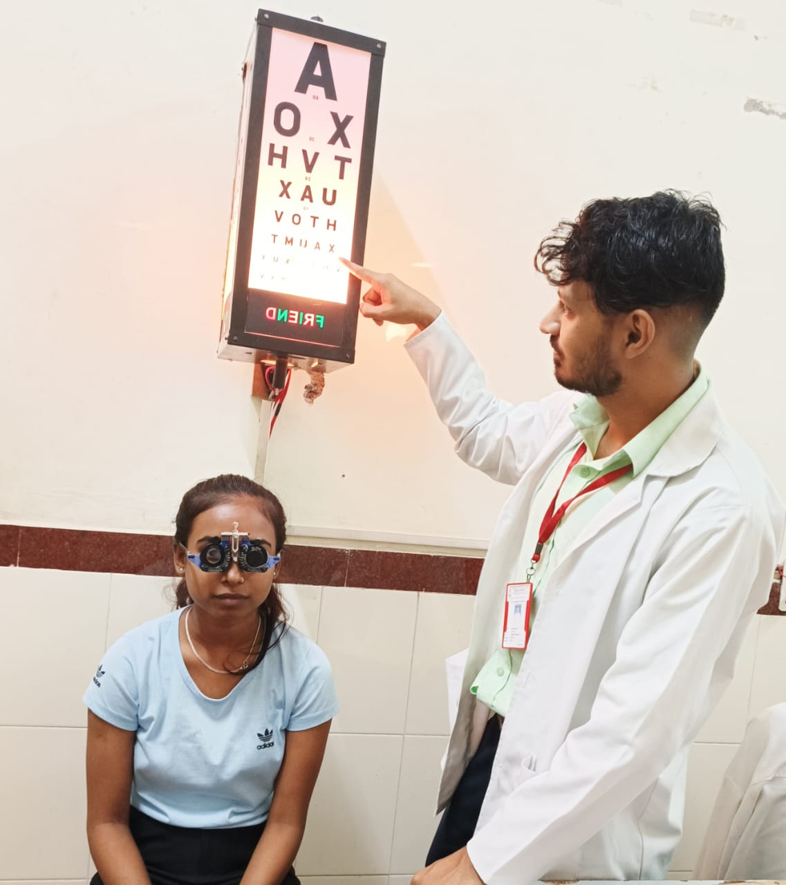

Fig 1.6 Examiner Conducting Refraction and Visual Accuracy

**Auto Refractometry**

An instrumented, objective method of calculating the refraction error is refractometry. Computerized auto refractometer use is expanding at the moment. By measuring the patients' refractive errors in terms of spherical, cylindrical with axis, and interpupillary distance, this gadget offers instantaneous insight.

Fig 1.7Assessor Performing Auto Refractometry

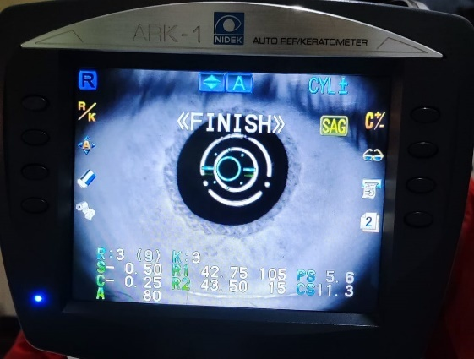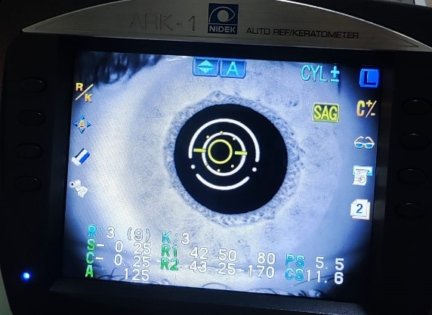

.

* **NON CONTACT TONOMETRY**

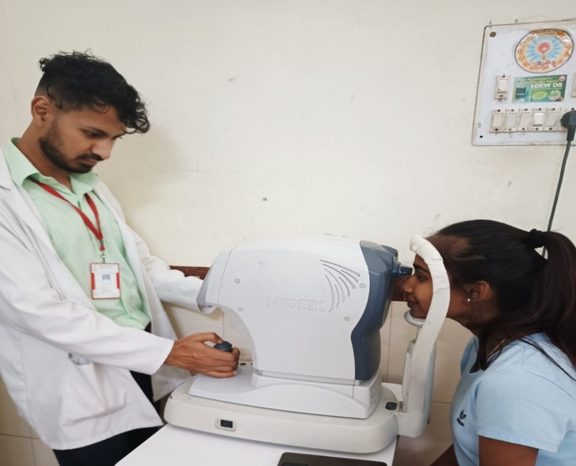NCT was made by Grolman and initially made available to the public in 1972. It is a diagnostic tool called an air puff tonometer that measures intraocular pressure. As suggested by the name, a "air puff" is used to quantify IOP.

Fig 1.9Examination for NCT

* **RETINOSCOPY**

It is sometimes referred to as the "skiascopy" or "shadow test," and it uses the neutralization method to determine refraction faults in an objective manner. It is based on the discovery that the refractive state of the eye controls the direction in which light will pass through the pupil when it is reflected from a mirror into the eye.

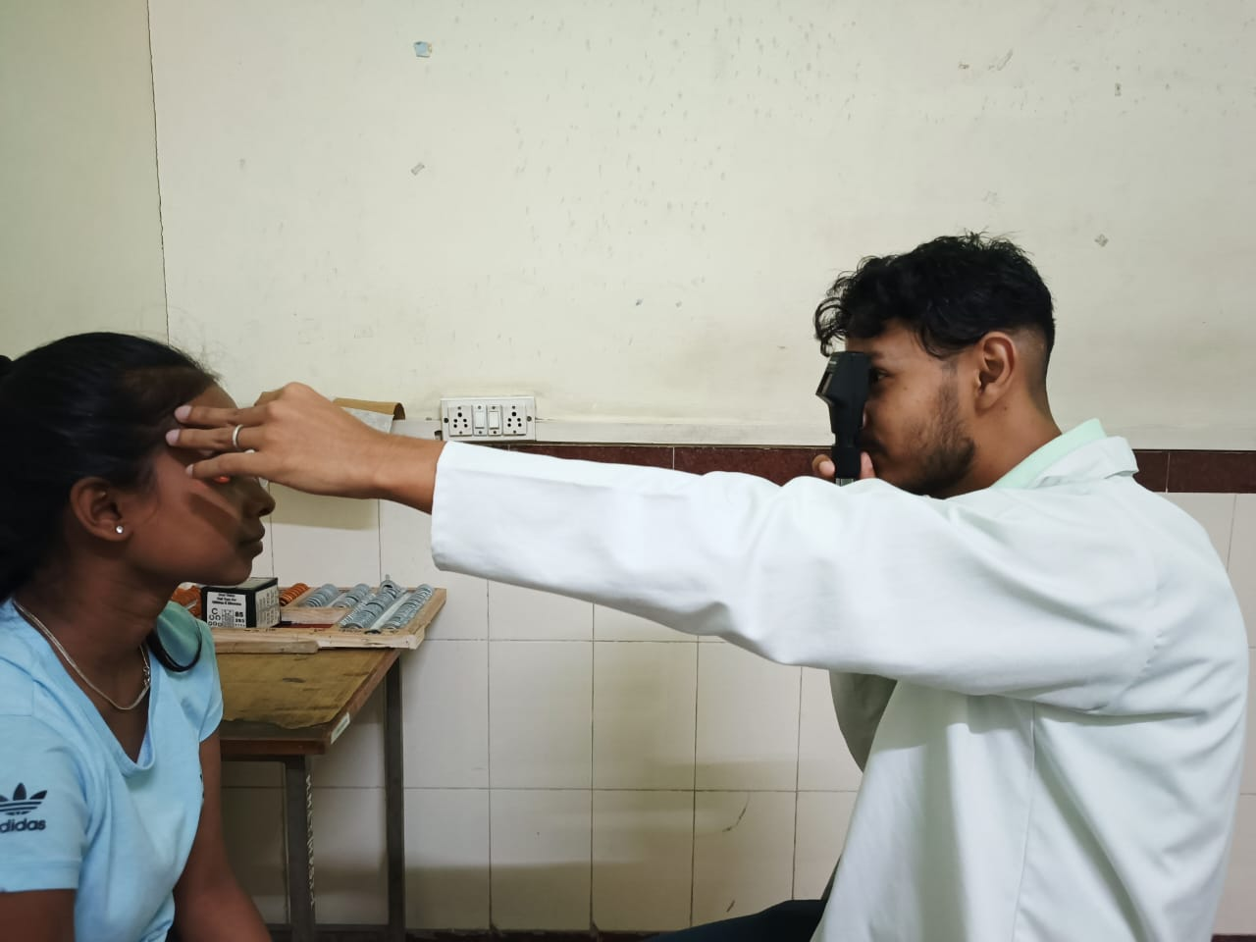

Fig 2.00 Retinoscopy by an Examiner



# **RESULT**

**RESULT**

Study was conducted on 100 patients between the age group of 10-30 years, in the Department of Ophthalmology of Maharishi Markandeshwar Institute of Medical Science and Research, Mullana, Ambala.

Figure 11 showed NPA with RAF Ruler and NPA with pen

|  |  |  |  |  |
| --- | --- | --- | --- | --- |
|  | Frequency | Percent | Valid Percent | Cumulative Percent |
| MYOPIA | 3 | 12.0 | 12.0 | 12.0 |
| HYPERMETROPIA | 1 | 4.0 | 4.0 | 16.0 |
| ASTIGMATISM | 21 | 84.0 | 84.0 | 100.0 |
| Total | 25 | 100.0 | 100.0 |  |

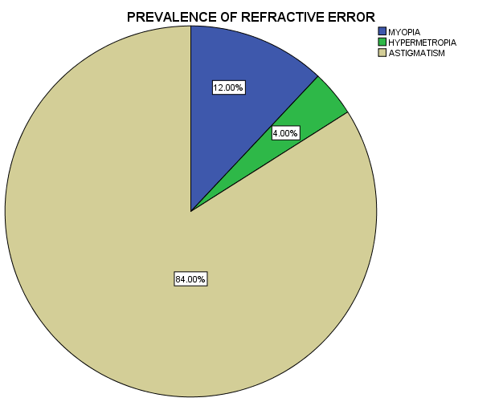

Figure 11 showed NPA with RAF Ruler and NPA with pen

|  |  |  |  |  |
| --- | --- | --- | --- | --- |
|  | Frequency | Percent | Valid Percent | Cumulative Percent |
| AMETROPIC AMBLYOPIA | 3 | 12.0 | 20.0 | 20.0 |
| ANISOMETROPIC AMBLYOPIA | 12 | 48.0 | 80.0 | 100.0 |
| Total | 15 | 60.0 | 100.0 |  |

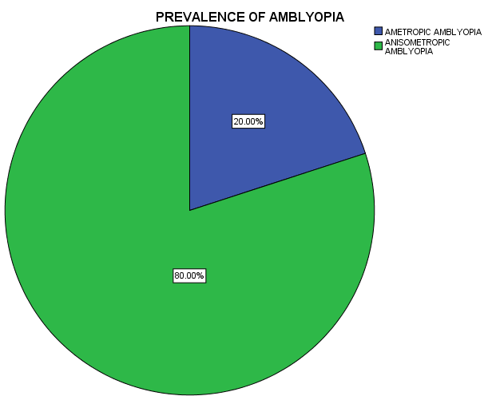

Out of 100 patients,30

21

****

# **DISCUSSION**

**DISCUSSION**

In our study, we found that NPA with RAF ruler had significant differences as comparison to NPA with PEN similar to study done by **Maheshwari R**.**et.al.,(2011)(21)**.

In our Study, Females 27 (13.37±10.49) are more affecting than Males 24 (9.92±5.99) patients but the data was not significant with Pen.

In our Study, Females 27 (16.81±12.12) are more affecting than Males 24 (12.04±6.15) patients but the data was not significant with RAF Ruler.

24

****

# **CONCLUSION**

# **AND**

# **LIMITATION**

**CONCLUSION**

In our study, we found that NPA with RAF ruler had significant differences in comparison to NPA with PEN.

**LIMITATIONS**

-Sample size was not sufficient, Time frame too less.

-Refractive Error ,NPC ,PBCT,NFV,PFV not taken due to time bound.

25



# **REFERENCES**

**REFERENCES**

1. ["Facts About Refractive Errors"](https://nei.nih.gov/health/errors/errors). NEI. October 2010. [Archived](https://web.archive.org/web/20160728000730/https:/nei.nih.gov/health/errors/errors) from the original on 28 July 2016. Retrieved 29 July 2016
2. JAIN ,A.K.(2018) .TEXT BOOK OF OPTICS AND REFRACTIVE ANOMALIES.CHAPTER 5.PAGE NO.86 CBS
3. KHURANA, A.K. (2018).Theory and practice of optics and refraction. chapter 5 page no. 80. ELSEVIER
4. Grosvenor T (July 1987). "A review and a suggested classification system for myopia on the basis of age-related prevalence and age of onset". American Journal of Optometry and Physiological Optics. **64** (7): 545–54. [doi](https://en.wikipedia.org/wiki/Doi_(identifier)):[10.1097/00006324-198707000-00012](https://doi.org/10.1097%2F00006324-198707000-00012). [PMID](https://en.wikipedia.org/wiki/PMID_(identifier)) [3307441](https://pubmed.ncbi.nlm.nih.gov/3307441).
5. Cline D, Hofstetter HW, Griffin JR (1997). Dictionary of Visual Science (4th ed.). Boston: Butterworth-Heinemann. [ISBN](https://en.wikipedia.org/wiki/ISBN_(identifier)) [978-0-7506-9895-5](https://en.wikipedia.org/wiki/Special:BookSources/978-0-7506-9895-5).
6. ["Glaucoma."](http://www.eyemdlink.com/Condition.asp?ConditionID=2) [Archived](https://web.archive.org/web/20060819160824/http:/www.eyemdlink.com/Condition.asp?ConditionID=2) 19 August 2006 at the [Wayback Machine](https://en.wikipedia.org/wiki/Wayback_Machine) EyeMDLink.com. Retrieved 27 August 2006.
7. Cline D, Hofstetter HW, Griffin JR (1997). Dictionary of Visual Science (4th ed.). Boston: Butterworth-Heinemann. [ISBN](https://en.wikipedia.org/wiki/ISBN_(identifier)) [978-0-7506-9895-5](https://en.wikipedia.org/wiki/Special:BookSources/978-0-7506-9895-5).
8. Zejmo, Maria; Formińska-Kapuścik, Maria; Pieczara, Ewa; Filipek, Erita; Mrukwa-Kominek, Ewa; Samochowiec-Donocik, Elzbieta; Leszczyński, Rafal; Smuzyńska, Magdalena (September 2009). ["Etiopathogenesis and management of high-degree myopia. Part I"](https://www.medscimonit.com/abstract/index/idArt/878169). Medical Science Monitor. **15** (9): RA199-202. [PMID](https://en.wikipedia.org/wiki/PMID_(identifier)) [19721411](https://pubmed.ncbi.nlm.nih.gov/19721411). [INIST](https://en.wikipedia.org/wiki/Institut_de_l%27information_scientifique_et_technique):[21992936](https://pascal-francis.inist.fr/vibad/index.php?action=getRecordDetail&idt=21992936).
9. [Retinal Detachment](https://emedicine.medscape.com/article/798501-overview) at [eMedicine](https://en.wikipedia.org/wiki/EMedicine)
10. ["More Information on Glaucoma."](https://web.archive.org/web/20040204164358/http:/www.agingeye.net/glaucoma/glaucomainformation.php) AgingEye Times. Retrieved 27 August 2006.
11. Messmer DE (May 1992). "[Retinal detachment]". SchweizerischeRundschaufürMedizin Praxis = Revue Suisse de Médecine Praxis (in German). **81** (19): 622–5. [PMID](https://en.wikipedia.org/wiki/PMID_(identifier)) [1589678](https://pubmed.ncbi.nlm.nih.gov/1589678).
12. KHURANA, A.K. (2018).Theory and practice of optics and refraction. chapter 5 page no. 81. ELSEVIER
13. American Optometric Association (1997). [Optometric Clinical Practice Guideline: Care of the Patient with Myopia](https://web.archive.org/web/20150122062311/http:/www.aoa.org/documents/optometrists/CPG-15.pdf) (PDF) (Report). Archived from [the original](http://www.aoa.org/documents/optometrists/CPG-15.pdf) (PDF) on 22 January 2015. Retrieved 17 February 2015.
14. Morgan I, Rose K (January 2005). "How genetic is school myopia?". Progress in Retinal and Eye Research. **24** (1): 1–38. [doi](https://en.wikipedia.org/wiki/Doi_(identifier)):[10.1016/j.preteyeres.2004.06.004](https://doi.org/10.1016%2Fj.preteyeres.2004.06.004). [PMID](https://en.wikipedia.org/wiki/PMID_(identifier)) [15555525](https://pubmed.ncbi.nlm.nih.gov/15555525). [S2CID](https://en.wikipedia.org/wiki/S2CID_(identifier)) [18045281](https://api.semanticscholar.org/CorpusID:18045281).
15. Cline D, Hofstetter HW, Griffin JR (1997). Dictionary of Visual Science (4th ed.). Boston: Butterworth-Heinemann. [ISBN](https://en.wikipedia.org/wiki/ISBN_(identifier)) [978-0-7506-9895-5](https://en.wikipedia.org/wiki/Special:BookSources/978-0-7506-9895-5).
16. Ryan et al.  Retina. 2013
17. Ohno-Matsui K. Pathologic myopia. Asia Pac J Ophthalmol 2016;5: 415–423.
18. Wong YL, Hysi P, Cheung G, Tedja M, Hoang QV, Tompson SWJ, et al. (2019) Genetic variants linked to myopic macular degeneration in persons with high myopia: CREAM Consortium. PLoS ONE 14(8): e0220143.
19. KHURANA, A.K. (2018).Theory and practice of optics and refraction. Chapter 3 page no. 84 .ELSEVIER
20. JAIN ,A.K.(2018) .TEXT BOOK OF OPTICS AND REFRACTIVE ANOMALIES.CHAPTER 5.PAGE NO.92 CBS
21. JAIN ,A.K.(2018) .TEXT BOOK OF OPTICS AND REFRACTIVE ANOMALIES.CHAPTER 5.PAGE NO.93 CBS
22. Cassin, B. and Solomon, S. (2001) Dictionary of Eye Terminology. Gainesville, Florida: Triad Publishing Company. [ISBN](https://en.wikipedia.org/wiki/ISBN_(identifier)) [0937404632](https://en.wikipedia.org/wiki/Special:BookSources/0937404632).
23. American Optometric Association (1997). [Optometric Clinical Practice Guideline: Care of the Patient with Myopia](https://web.archive.org/web/20150122062311/http:/www.aoa.org/documents/optometrists/CPG-15.pdf) (PDF) (Report). Archived from [the original](http://www.aoa.org/documents/optometrists/CPG-15.pdf) (PDF) on 22 January 2015. Retrieved 17 February 2015.
24. KHURANA, A.K. (2015). Comprehensive Ophthalmology(6th ed) . chapter 4 page no. 41. JAYPEE
25. Pallikaris IG, Siganos DS (1997). "Laser in situ keratomileusis to treat myopia: early experience". Journal of Cataract and Refractive Surgery. **23** (1): 39–49. [doi](https://en.wikipedia.org/wiki/Doi_(identifier)):[10.1016/s0886-3350(97)80149-6](https://doi.org/10.1016%2Fs0886-3350%2897%2980149-6). [PMID](https://en.wikipedia.org/wiki/PMID_(identifier)) [9100106](https://pubmed.ncbi.nlm.nih.gov/9100106). [S2CID](https://en.wikipedia.org/wiki/S2CID_(identifier)) [38655546](https://api.semanticscholar.org/CorpusID:38655546).
26. Pallikaris IG, Kymionis GD, Astyrakakis NI (November 2001). "Corneal ectasia induced by laser in situ keratomileusis". Journal of Cataract and Refractive Surgery. **27** (11): 1796–802. [doi](https://en.wikipedia.org/wiki/Doi_(identifier)):[10.1016/s0886-3350(01)01090-2](https://doi.org/10.1016%2Fs0886-3350%2801%2901090-2). [PMID](https://en.wikipedia.org/wiki/PMID_(identifier)) [11709254](https://pubmed.ncbi.nlm.nih.gov/11709254). [S2CID](https://en.wikipedia.org/wiki/S2CID_(identifier)) [2333450](https://api.semanticscholar.org/CorpusID:2333450).
27. Trokel SL, Srinivasan R, Braren B (December 1983). "Excimer laser surgery of the cornea". American Journal of Ophthalmology. **96** (6): 710–5. [doi](https://en.wikipedia.org/wiki/Doi_(identifier)):[10.1016/s0002-9394(14)71911-7](https://doi.org/10.1016%2Fs0002-9394%2814%2971911-7). [PMID](https://en.wikipedia.org/wiki/PMID_(identifier)) [6660257](https://pubmed.ncbi.nlm.nih.gov/6660257).
28. Seiler T, Bende T, Wollensak J, Trokel S (February 1988). "Excimer laser keratectomy for correction of astigmatism". American Journal of Ophthalmology. **105** (2): 117–24. [doi](https://en.wikipedia.org/wiki/Doi_(identifier)):[10.1016/0002-9394(88)90173-0](https://doi.org/10.1016%2F0002-9394%2888%2990173-0). [PMID](https://en.wikipedia.org/wiki/PMID_(identifier)) [3341427](https://pubmed.ncbi.nlm.nih.gov/3341427).
29. Bates, Wm H (1920) [Sight Without Glasses](https://en.wikisource.org/wiki/Perfect_Sight_Without_Glasses/Chapter_10) [Archived](https://web.archive.org/web/20161220174710/https:/en.wikisource.org/wiki/Perfect_Sight_Without_Glasses/Chapter_10) 20 December 2016 at the [Wayback Machine](https://en.wikipedia.org/wiki/Wayback_Machine). Ch. 10, p. 106. [ISBN](https://en.wikipedia.org/wiki/ISBN_(identifier)) [1479118540](https://en.wikipedia.org/wiki/Special:BookSources/1479118540).
30. Barrett BT (January 2009). ["A critical evaluation of the evidence supporting the practice of behavioural vision therapy"](https://doi.org/10.1111%2Fj.1475-1313.2008.00607.x). Ophthalmic & Physiological Optics. **29** (1): 4–25. [doi](https://en.wikipedia.org/wiki/Doi_(identifier)):[10.1111/j.1475-1313.2008.00607.x](https://doi.org/10.1111%2Fj.1475-1313.2008.00607.x). [PMID](https://en.wikipedia.org/wiki/PMID_(identifier)) [19154276](https://pubmed.ncbi.nlm.nih.gov/19154276). [S2CID](https://en.wikipedia.org/wiki/S2CID_(identifier)) [13588501](https://api.semanticscholar.org/CorpusID:13588501).
31. Ramjit, Sihota; Radhika, Tandon (15 July 2015). "Refractive errors of the eye". Parsons' diseases of the eye (22nd ed.). Elsevier. [ISBN](https://en.wikipedia.org/wiki/ISBN_(identifier)) [978-81-312-3818-9](https://en.wikipedia.org/wiki/Special:BookSources/978-81-312-3818-9).
32. Lowth, Mary. ["Long Sight (Hypermetropia)"](http://patient.info/health/long-sight-hypermetropia). Patient. Patient Platform Limited. [Archived](https://web.archive.org/web/20160303133100/http:/patient.info/health/long-sight-hypermetropia) from the original on 2016-03-03. Retrieved 2016-02-26.
33. Khurana, AK (September 2008). "Errors of refraction and binocular optical defects". Theory and practice of optics and refraction (2nd ed.). Elsevier. pp. 62–66. [ISBN](https://en.wikipedia.org/wiki/ISBN_(identifier)) [978-81-312-1132-8](https://en.wikipedia.org/wiki/Special:BookSources/978-81-312-1132-8).
34. Khurana, AK (2015). "Errors of refraction and accommodation". Comprehensive ophthalmology (6th ed.). Jaypee, The Health Sciences Publisher. pp. 37–38. [ISBN](https://en.wikipedia.org/wiki/ISBN_(identifier)) [978-93-86056-59-7](https://en.wikipedia.org/wiki/Special:BookSources/978-93-86056-59-7).
35. Moore, Bruce D.; Augsburger, Arol R.; Ciner, Elise B.; Cockrell, David A.; Fern, Karen D.; Harb, Elise (2008). ["Optometric Clinical Practice Guideline: Care of the Patient with Hyperopia"](https://web.archive.org/web/20060717040622/http:/www.aoa.org/documents/CPG-16.pdf) (PDF). American Optometric Association. pp. 2–3, 10–11. Archived from [the original](http://www.aoa.org/documents/CPG-16.pdf) (PDF) on 2006-07-17. Retrieved 2006-06-18.
36. KHURANA, A.K. (2018).Theory and practice of optics and refraction. Chapter 3 page no.71.ELSEVIER
37. KHURANA, A.K. (2015). Comprehensive Ophthalmology(6th ed) . chapter 4 page no. 36 JAYPEE
38. ["Complications of long-sightedness"](https://web.archive.org/web/20160305225225/http:/www.nhs.uk/Conditions/Long-sightedness/Pages/Complications.aspx). NHS Choices. National Health Service. 2014-07-09. Archived from [the original](http://www.nhs.uk/Conditions/Long-sightedness/Pages/Complications.aspx) on 2016-03-05. Retrieved 2016-02-26.
39. KHURANA, A.K. (2018).Theory and practice of optics and refraction. chapter 3 page no. 74. ELSEVIER
40. Alió, Jorge L.; Grzybowski, Andrzej; Romaniuk, Dorota (2014-12-10). ["Refractive lens exchange in modern practice: when and when not to do it?"](https://www.ncbi.nlm.nih.gov/pmc/articles/PMC4655463). Eye and Vision. **1**: 10. [doi](https://en.wikipedia.org/wiki/Doi_(identifier)):[10.1186/s40662-014-0010-2](https://doi.org/10.1186%2Fs40662-014-0010-2). [ISSN](https://en.wikipedia.org/wiki/ISSN_(identifier)) [2326-0254](https://www.worldcat.org/issn/2326-0254). [PMC](https://en.wikipedia.org/wiki/PMC_(identifier)) [4655463](https://www.ncbi.nlm.nih.gov/pmc/articles/PMC4655463). [PMID](https://en.wikipedia.org/wiki/PMID_(identifier)) [26605356](https://pubmed.ncbi.nlm.nih.gov/26605356). [open access](https://en.wikipedia.org/wiki/Open_access)
41. Khurana, AK (September 2008). "Refractive surgery". Theory and practice of optics and refraction (2nd ed.). Elsevier. pp. 307–348. [ISBN](https://en.wikipedia.org/wiki/ISBN_(identifier)) [978-81-312-1132-8](https://en.wikipedia.org/wiki/Special:BookSources/978-81-312-1132-8).
42. Arun C, Gulani (9 November 2019). ["LASIK Hyperopia: Background, History of the Procedure, Problem"](https://emedicine.medscape.com/article/1221098-overview).
43. ["Facts About Astigmatism"](https://web.archive.org/web/20161002081657/https:/nei.nih.gov/health/errors/astigmatism). National Eye Institute. October 2010. Archived from the original on 2 October 2016. Retrieved 22 December 2019.
44. ["The Ultimate Guide to Astigmatism"](https://www.feelgoodcontacts.com/guide-to-astigmatism#:~:text=A%20high%20astigmatism%20refers%20to,with%20severe%20astigmatism%20would%20see.). Feel Good Contacts.
45. Harvey, EM (June 2009). ["Development and treatment of astigmatism-related amblyopia"](https://www.ncbi.nlm.nih.gov/pmc/articles/PMC2706277). Optometry and Vision Science. **86** (6): 634–9. [doi](https://en.wikipedia.org/wiki/Doi_(identifier)):[10.1097/opx.0b013e3181a6165f](https://doi.org/10.1097%2Fopx.0b013e3181a6165f). [PMC](https://en.wikipedia.org/wiki/PMC_(identifier)) [2706277](https://www.ncbi.nlm.nih.gov/pmc/articles/PMC2706277). [PMID](https://en.wikipedia.org/wiki/PMID_(identifier)) [19430327](https://pubmed.ncbi.nlm.nih.gov/19430327).
46. KHURANA, A.K. (2015). Comprehensive Ophthalmology(6th ed) . chapter 4 page no. 42. JAYPEE
47. Gilbert Smolin; Charles Stephen Foster; Dimitri T. Azar; Claes H. Dohlman (2005). [Smolin and Thoft's The Cornea: Scientific Foundations and Clinical Practice](https://books.google.com/books?id=93s6aes5ob0C&pg=PA173). Lippincott Williams & Wilkins. pp. 173–. [ISBN](https://en.wikipedia.org/wiki/ISBN_(identifier)) [978-0-7817-4206-1](https://en.wikipedia.org/wiki/Special:BookSources/978-0-7817-4206-1).
48. KHURANA, A.K. (2018).Theory and practice of optics and refraction. Chapter 3 page no.88.ELSEVIER
49. KHURANA, A.K. (2015). Comprehensive Ophthalmology (6th ed) .chapter 4 page no. 43. JAYPEE
50. ["Astigmatism"](https://web.archive.org/web/20130702055701/http:/www.onhealth.com/astigmatism/article.htm). MedicineNet. OnHealth.com. Archived from [the original](http://www.onhealth.com/astigmatism/article.htm) on 2 July 2013. Retrieved 8 September 2013.
51. Harle, Deacon E.; Evans, Bruce J. W. (2006). "The Correlation Between Migraine Headache and Refractive Errors". Optometry and Vision Science. **83** (2): 82–7. [doi](https://en.wikipedia.org/wiki/Doi_(identifier)):[10.1097/01.opx.0000200680.95968.3e](https://doi.org/10.1097%2F01.opx.0000200680.95968.3e). [PMID](https://en.wikipedia.org/wiki/PMID_(identifier)) [16501409](https://pubmed.ncbi.nlm.nih.gov/16501409). [S2CID](https://en.wikipedia.org/wiki/S2CID_(identifier)) [32019102](https://api.semanticscholar.org/CorpusID:32019102).
52. ["Facts About Astigmatism"](https://nei.nih.gov/health/errors/astigmatism). National Eye Institute. National Institutes of Health. Retrieved 16 June 2019.
53. Lake, Jonathan C; Victor, Gustavo; Clare, Gerry; Porfírio, Gustavo JM; Kernohan, Ashleigh; Evans, Jennifer R (17 December 2019). Cochrane Eyes and Vision Group (ed.). ["Toric intraocular lens versus limbal relaxing incisions for corneal astigmatism after phacoemulsification"](https://www.ncbi.nlm.nih.gov/pmc/articles/PMC6916141). Cochrane Database of Systematic Reviews. **2019** (12): CD012801. [doi](https://en.wikipedia.org/wiki/Doi_(identifier)):[10.1002/14651858.CD012801.pub2](https://doi.org/10.1002%2F14651858.CD012801.pub2). [PMC](https://en.wikipedia.org/wiki/PMC_(identifier)) [6916141](https://www.ncbi.nlm.nih.gov/pmc/articles/PMC6916141). [PMID](https://en.wikipedia.org/wiki/PMID_(identifier)) [31845757](https://pubmed.ncbi.nlm.nih.gov/31845757).
54. Mustafa, Osama M.; Prescott, Christina; Alsaleh, Fares; Dzhaber, Daliya; Daoud, Yassine J. (2019). "Refractive and Visual Outcomes and Rotational Stability of Toric Intraocular Lenses in Eyes With and Without Previous Ocular Surgeries: A Longitudinal Study". Journal of Refractive Surgery. **35** (12): 781–788. [doi](https://en.wikipedia.org/wiki/Doi_(identifier)):10.3928/1081597x-20191021-03. [ISSN](https://en.wikipedia.org/wiki/ISSN_(identifier)) [1081-597X](https://www.worldcat.org/issn/1081-597X). [PMID](https://en.wikipedia.org/wiki/PMID_(identifier)) [31830294](https://pubmed.ncbi.nlm.nih.gov/31830294). [S2CID](https://en.wikipedia.org/wiki/S2CID_(identifier)) [209341790](https://api.semanticscholar.org/CorpusID:209341790).
55. ["Facts About Amblyopia"](https://nei.nih.gov/health/amblyopia/amblyopia_guide). National Eye Institute. September 2013. [Archived](https://web.archive.org/web/20160727233820/https:/nei.nih.gov/health/amblyopia/amblyopia_guide) from the original on 27 July 2016. Retrieved 27 July 2016.
56. Jefferis JM, Connor AJ, Clarke MP (November 2015). "Amblyopia". BMJ. **351**: h5811. [doi](https://en.wikipedia.org/wiki/Doi_(identifier)):[10.1136/bmj.h5811](https://doi.org/10.1136%2Fbmj.h5811). [PMID](https://en.wikipedia.org/wiki/PMID_(identifier)) [26563241](https://pubmed.ncbi.nlm.nih.gov/26563241). [S2CID](https://en.wikipedia.org/wiki/S2CID_(identifier)) [220101666](https://api.semanticscholar.org/CorpusID:220101666).
57. Webber AL, Wood J (November 2005). ["Amblyopia: prevalence, natural history, functional effects and treatment"](https://doi.org/10.1111%2Fj.1444-0938.2005.tb05102.x). Clinical & Experimental Optometry. **88** (6): 365–75. [doi](https://en.wikipedia.org/wiki/Doi_(identifier)):[10.1111/j.1444-0938.2005.tb05102.x](https://doi.org/10.1111%2Fj.1444-0938.2005.tb05102.x). [PMID](https://en.wikipedia.org/wiki/PMID_(identifier)) [16329744](https://pubmed.ncbi.nlm.nih.gov/16329744). [S2CID](https://en.wikipedia.org/wiki/S2CID_(identifier)) [39141527](https://api.semanticscholar.org/CorpusID:39141527).
58. KHURANA, A.K (2018).Theory and practice of squint and orthoptics. Chapter 8.page no.141. CBS.
59. KHURANA, A.K. (2015). Comprehensive Ophthalmology(6th ed) . chapter 14 page no. 342JAYPEE
60. Hess RF, Mansouri B, Dakin SC, Allen HA (May 2006). "Integration of local motion is normal in amblyopia". Journal of the Optical Society of America A. **23** (5): 986–92. [Bibcode](https://en.wikipedia.org/wiki/Bibcode_(identifier)):[2006JOSAA..23..986H](https://ui.adsabs.harvard.edu/abs/2006JOSAA..23..986H). [doi](https://en.wikipedia.org/wiki/Doi_(identifier)):[10.1364/JOSAA.23.000986](https://doi.org/10.1364%2FJOSAA.23.000986). [PMID](https://en.wikipedia.org/wiki/PMID_(identifier)) [16642175](https://pubmed.ncbi.nlm.nih.gov/16642175).
61. Polat U, Ma-Naim T, Belkin M, Sagi D (April 2004). ["Improving vision in adult amblyopia by perceptual learning"](https://www.ncbi.nlm.nih.gov/pmc/articles/PMC404107). Proceedings of the National Academy of Sciences of the United States of America. **101** (17): 6692–7. [Bibcode](https://en.wikipedia.org/wiki/Bibcode_(identifier)):[2004PNAS..101.6692P](https://ui.adsabs.harvard.edu/abs/2004PNAS..101.6692P). [doi](https://en.wikipedia.org/wiki/Doi_(identifier)):[10.1073/pnas.0401200101](https://doi.org/10.1073%2Fpnas.0401200101). [PMC](https://en.wikipedia.org/wiki/PMC_(identifier)) [404107](https://www.ncbi.nlm.nih.gov/pmc/articles/PMC404107). [PMID](https://en.wikipedia.org/wiki/PMID_(identifier)) [15096608](https://pubmed.ncbi.nlm.nih.gov/15096608).
62. Levi, Dennis M.; Song, Shuang; Pelli, Denis G. (2007). ["Amblyopic reading is crowded"](https://doi.org/10.1167%2F7.2.21). Journal of Vision. **7** (2): 21.1–17. [doi](https://en.wikipedia.org/wiki/Doi_(identifier)):[10.1167/7.2.21](https://doi.org/10.1167%2F7.2.21). [ISSN](https://en.wikipedia.org/wiki/ISSN_(identifier)) [1534-7362](https://www.worldcat.org/issn/1534-7362). [PMID](https://en.wikipedia.org/wiki/PMID_(identifier)) [18217836](https://pubmed.ncbi.nlm.nih.gov/18217836).
63. Tyler CW (2004). Tasman W, Jaeger EA (eds.). Binocular Vision In, Duane's Foundations of Clinical Ophthalmology. Vol. 2. Philadelphia: J.B. Lippincott Co.
64. KHURANA, A.K. (2015). Comprehensive Ophthalmology (6th ed) .chapter 14 page no. 343. JAYPEE
65. Epelbaum M, Milleret C, Buisseret P, Duffer JL. The sensitive period for strabismic amblyopia in humans. Ophthalmology. 1993 Mar 1;100(3):323-7.
66. Murthy GV, Gupta SK, Ellwein LB, Munoz SR, Pokharel GP, Sanga L, Bachani D. Refractive error in children in an urban population in New Delhi. Investigative ophthalmology & visual science. 2002 Mar 1;43(3):623-31.
67. Faghihi M. The prevalence of refractive errors, strabismus and amblyopia in schoolboys of Varamin, Iran, in 2010. Journal of Current Ophthalmology. 2012 Apr 1;24(2):33.
68. Pokharel A, Pokharel PK, Das H, Adhikari S. The patterns of refractive errors among the school children of rural and urban settings in Nepal. Nepalese Journal of Ophthalmology. 2010 Sep 17;2(2):114-20.
69. Rai SK, Thapa HB, Sharma MK, Dhakhwa K, Karki R. The distribution of refractive errors among children attending Lumbini Eye Institute, Nepal. Nepalese Journal of Ophthalmology. 2012;4(1):90-5.
70. Sapkota K, Pirouzian A, Matta NS. Prevalence of amblyopia and patterns of refractive error in the amblyopic children of a tertiary eye care center of Nepal. Nepalese Journal of Ophthalmology. 2013 Mar 25;5(1):38-44.
71. Pavithra MB, Maheshwaran R, Sujatha R. A study on the prevalence of refractive errors among school childern of 7-15 years age group in the field practice areas of a medical college in bangalore.
72. Gupta M, Rana SK, Mittal SK, Sinha RN. Profile of amblyopia in school going (5-15 years) children at state level referral hospital in Uttarakhand. Journal of clinical and diagnostic research: JCDR. 2016 Nov;10(11):SC09.
73. WA H, TF A, DG A, SA D. Prevalence and types of amblyopia among primary school children in Gondar town, Northwest Ethiopia.
74. Pradhan N, Sachdeva A, Goel T, Bhola B, Jha D. Prevalence of refractive errors among school children of 6-12-years of age group and reason for not using spectacles even after correction. Int J Res Med Sci. 2018 Mar;6(3):798-801.
75. Daigavane S, Prasad M. To observe the proportion of amblyopia among children presenting in a rural hospital in Central India. Journal of DattaMeghe Institute of Medical Sciences University. 2018 Jul 1;13.
76. Ezhilvathani N, Suruthi P, Jeiganesh M. Profile of refractive errors and amblyopia in 5–15 yrs of school going children at a Union territory tertiary health centre. Int. J. Res. Med. Sci. 2019 May;7:1929-33.
77. Bhatnagar DG, Kumar A, Kumar R. Prevalence of Amblyopia among School Children in Faridabad, Haryana.

28



# **ABBREVIATIONS & ANNEXURES**

**ABBREVIATIONS**

**ABBREVIATIONS**

VA=visual acuity

SE=spherical equivalent

CI =confidence interval

RR= refractive error

NEH=Nepal eye hospital

OPD= Out Patient department

TVS= Television

SS= Sample size

LASIK= Laser in -situkeratomileusis

PRK= Photorefractive keratectomy

29

**CASE REPORT PERFORMA**

**Date - ......................**

**Name -................. Age-............. Gender -..................**

**V.A. - (Best corrected)**

**REFRACTIVE ERROR**

**AMBLYOPIA**

31



# **MASTER**

# **CHART**

|  |  |  |  |  |  |  |  |  |  |  |  |  |
| --- | --- | --- | --- | --- | --- | --- | --- | --- | --- | --- | --- | --- |
|  |  |  |  |  | **REFRACTION** | | | | | | | |
|  |  |  |  |  | **OD** | | | | **OS** | | | |
| **SR.NO** | **UMR NO.** | **NAME** | **AGE** | **GENDER** | **SPH** | **CYL** | **AXIS** | **VA (LOG MAR)** | **SPH** | **CYL** | **AXIS** | **VA(LOG MAR)** |
| 1 | 202205120323 | MASTER KUSHAL | 11 | MALE | 4.5 | 0 | 0 | 0.6 | 4 | 0.5 | 110 | 0.6 |
| 2 | 202205120159 | DAMANI | 6 | FEMALE | 5.75 | 1 | 95 | 0.75 | 4.5 | 75 | 85 | 0.75 |
| 3 | 202206280601 | MANTHAN RANA | 6 | FEMALE | 0 | 0.5 | 75 | 0.2 | 0.5 | -1 | 180 | 0.25 |
| 4 | 202206280507 | RUDRA SHARMA | 11 | MALE | -1.75 | -0.5 | 180 | 0 | -1.5 | -0.5 | 170 | 0 |
| 5 | 202206280502 | LAVANSH MALIK | 12 | MALE | 0 | -0.5 | 10 | 0 | 0 | -0.75 | 175 | 0 |
| 6 | 202206280508 | SHITISH SINGH MAJARI | 13 | MALE | 0 | 0 | 0 | 0 | 0.5 | 0 | 0 | 0 |
| 7 | 202206280162 | KHUSHPREET | 10 | FEMALE | -1 | -1.25 | 180 | 0 | -1 | -1.25 | 175 | 0 |
| 8 | 202206270058 | MOHAMAD IJJAN | 10 | MALE | 0 | 0.5 | 100 | 0 | 0 | 0 | 0 | 1.5 |
| 9 | 202206270367 | MASTER DASMEET | 7 | MALE | -5 | -1.25 | 175 | 0.3 | -4.5 | -1.75 | 175 | 0.3 |
| 10 | 202206240864 | NIRIHIKA | 10 | FEMALE | 0 | -0.5 | 170 | 0 | 0 | -0.5 | 175 | 0 |
| 11 | 202206060039 | MADHAV | 11 | MALE | -2 | 0 | 0 | 0 | -1.5 | 0 | 0 | 0 |
| 12 | 202206040076 | ISHMEET KAUR | 14 | FEMALE | 0 | -0.5 | 180 | 0 | 0 | -0.5 | 180 | 0 |
| 13 | 202207290422 | SHIFAYAT | 11 | MALE | -1.75 | 0 | 0 | 0 | -2 | 0 | 0 | 0 |
| 14 | 202207280543 | JAYA | 11 | FEMALE | -0.5 | 0 | 0 | 0 | -0.75 | 0 | 0 | 0 |
| 15 | 202207230550 | HARSHIV | 9 | MALE | -2 | 0 | 0 | 0 | -2 | 0 | 0 | 0 |
| 16 | 202207140260 | MANVI | 10 | FEMALE | -3 | -2.75 | 20 | 0 | -3 | -2.75 | 165 | 0 |
| 17 | 202206250532 | PRANJAL | 18 | MALE | -4.75 | -2.5 | 175 | 0 | -2 | -3.75 | 175 | 0 |
| 18 | 202206210202 | RIDHI | 11 | FEMALE | 0 | -2 | 180 | 0 | 0 | -2 | 145 | 0 |
| 19 | 202204190428 | ANISH | 10 | MALE | -7 | -2 | 10 | 0.3 | -7 | -2 | 5 | 0.3 |
| 20 | 202208030235 | ANANDITA | 16 | FEMALE | -4.25 | -1.5 | 180 | 0 | -2.75 | -1.5 | 180 | 0 |
| 21 | 202207270507 | HIMANSHU | 9 | MALE | 0 | -3.25 | 180 | 0.3 | 0 | -1.5 | 170 | 0.2 |
| 22 | 202206040180 | GURJIT | 20 | MALE | 0 | 0 | 0 | 0.75 | 0 | 0 | 0 | 0.75 |
| 23 | 202204190078 | ADITYA | 17 | MALE | -4.5 | -0.75 | 10 | 0 | -4.5 | -0.75 | 170 | 0 |
| 24 | 202204190114 | VIDHAN | 11 | MALE | -1.75 | -0.5 | 15 | 0.2 | -1.75 | -0.5 | 180 | 0.2 |
| 25 | 202207190217 | ABDUL BASHIT | 14 | MALE | -7.5 | -0.75 | 35 | 0.2 | -10 | 0 | 0 | 1.5 |